**Library Management System**

(An Approach to make Library Management easy)



**Developer Team**

Meer Hamza **(team leader) 2019-CS-29**

Maimoon Ahmed **2019-CS-42**

Ameer Baksh **2019-CS-28**

Hassan Wasti **2019-CS-40**

Umar Farooq **2019-CS-27**

**Roles:**

* Mr. Meer Hamza as the **team leader** did an excellent job of guiding all of the participants and helping them out in any way possible. He divided the projects roles by judging the capabilities of each member and made it easy for everyone to work smoothly and as efficiently as possible. He played the major role of developing the **GUI,** Integrating the members class with the GUI and **developing various logics** to make the GUI functional all the while consulting us too make it as appealing as possible.
* Mr. Maimoon Ahmed is a worthy comrade who played a key role in designing of **GUI** through his excellent ideas. He also designed a ‘Class’ name **Borrowing** and also managed software’s file handling. He is also the Co-Author of this documentation.
* Mr. Ameer Baksh is an exceptional programmer played a good role as a companion in development of project and designed ‘Class’ **Content** and its sub classes like **Book, Articles** etc.
* Mr. Hassan Wasti despite having communication gaps and less programming skills, tried his best and played a healthy role in development of project by designing ‘Class’  **Subscribers.**
* Mr. Umar Farooq despite having less programming and problem solving skills played a crucial role in **development** and **designing** of project through his exceptional ideas and also designed a key ‘Class’ **Library** for project.

**Requirement**

The basic purpose of development of this **product** is to give/submit it as a **semester final project**. Client (Teacher of this subject) required us to build a software to manage **Libraries related stuff**. A software which is capable to deal with **Admin** and **Subscribers** simultaneously.

**In Admin Section**, it is required to create a password protected section only for admin which ensures Security and allows only the Admin to **Add**, **Edit**, **Delete** and view **Report** of **Overdue** items.

**In Adding item section**, it is required that the Admin always assigns a **unique item id** to a **particular item** while adding it and if accidently the Admin gives a **previous id** to a **new item** while **adding,** it informs the Admin that this **item already exist** through its **particular id** and it also restricts the admin to **fill all fields of data** and if **unintentionally** the admin left a **field empty** it informs the admin that all fields not filled. It also **restricts** the Admin to fill **valid data,** as in **publishing year** of an item it restricts the **Admin** to fill it with a **Valid Year** like **2010.**

**In Editing item section**, it is required when the admin wants to **Edit the specs of an item** it restricts the Admin to give **particular id** of that item to ensures **editing of right item** and avoid **data loss or overwriting** of previous data of another item and if the id of this item **does not exist** it simply **informs the Admin** and it also follow same **validation trends** of **Adding section**.

**In Deleting item section**, it is require when the Admin wants to **delete an item,** it restricts the Admin to give **particular id** of that item to ensure **Deleting of right item** and avoid **data loss** and if id of the item **does not exist** it simply informs the Admin.

**In Overdue Items Report Section,** it gives a **complete report** to the **Admin**, of **late items** which isn’t **returned yet** and also gives the **subscriber id** of the User/Subscriber who **borrowed** **this item** and also gives the **borrowed items id** and tells the **late** **return fine** of the User/Subscriber.

**In Subscriber’s Section**, We require two Options a **Login option** for the **previous Subscribers** and a **register option** to become a **new subscriber.**

**In Subscriber’s Register Section,** we required an **interface** which facilitates the User to **register** as a new Subscriber. The user simply enter his/her name, choose a **password** for her/himself which is also the **User’s Subscriber Id** which assist him/her to **login** as a Subscriber. Enter his\her **Address, Phone Number and Email** for contact purposes. We also assured that the **Password** enter by the User should be **unique and never exist** before otherwise it should **inform** the user and compelled to enter a different Password.

**In Subscriber’s Login Section**, we required a **password protected Section** for the **previous Subscribers** which allows a **particular subscriber** to **login** to the **Subscriber section** and give access to the Subscriber’s options through their **particular subscriber Id** to ensure **Security**. We also supposed to provide an option of **Reset Password** to allow the User/Subscriber to reset its Subscriber’s Id through its Phone Number in case he/she forget his/her password. This Section contain **three options** Borrow an item**,** Return an item, and View available items**.**

**In Borrow an Item Section,** it is required the Subscriber can get the **desired item** through this **item’s particular id** to ensures giving of **right item** and if the **item’s** **id** does not exist or the item is **not available** at that instance it simply informs the Subscriber and if the numbers of copies of the item become ‘0’ it set its **status to ‘not available’** and **denied** to give that item.

**In Return an Item Section**, it is required the Subscriber can **return** the **borrowed item** to its **particular Id** to ensure returning of **right item** and if the **User/Subscriber** accidentally enter **wrong Id** it informs the **User/Subscriber** and if the **number of copies** of this item is **zero** it increment a **one** in it and change its **status** from **“not available”** to **“Available or on the shelf”** and also tell the Subscriber the amount of fine in case of late return if the Subscriber is a **Regular** member then he/she has **30 days** to return an item and if Subscriber is a **Golden** member then he/she has **90 days** to return an item.

**In View Available Items Section,** it is required the Subscriber can view a **list of all available items**. The Name, Id and Author Name of item should be displayed in a **proper format** to facilitate **User/Subscriber** and to assist User/Subscriber to select the item he/she want to **borrow** through this **list** of available items.

It is also required to make a **mechanism** to keep the record of items, register Subscribers, Borrowed items, Returned items and fine and also use this data each and every we use this product and make it assured no data loss occur.

**UML Design for Library Management System**

|  |
| --- |
| **Contents** |
| -Item ID: string  -Category: string  -Title: string  -Author: string  -Publisher: string  -Production Year: Int  -Status: string  -Copies: Int |
| +Content()  +Setters: void  +Getters: depends on data types |

|  |
| --- |
| **Library** |
| -Library ID: Int  -Library Name: String |
| +Library()  +Setters: void  +Getters: depends on data types |

|  |
| --- |
| **Borrowing** |
| -subscriberID: string  -Content ID: date  -BorrowDate: date  -ReturnDate: date  -Fee: double |
| + Borrowing()  +Setters: void  +Getters: depends on data types |

|  |
| --- |
| **Subscribers** |
| -Subscriber ID: string  -Type: string  -Name: string  -Address: string  -Phone: string  -Email: string |
| +Subscriber()  +Setters: void  +Getters: depends on data types |

**Technical Explanation of code**

**Classes Designing Part:**

This part explains each and every thing of our code and its working so let’s started.

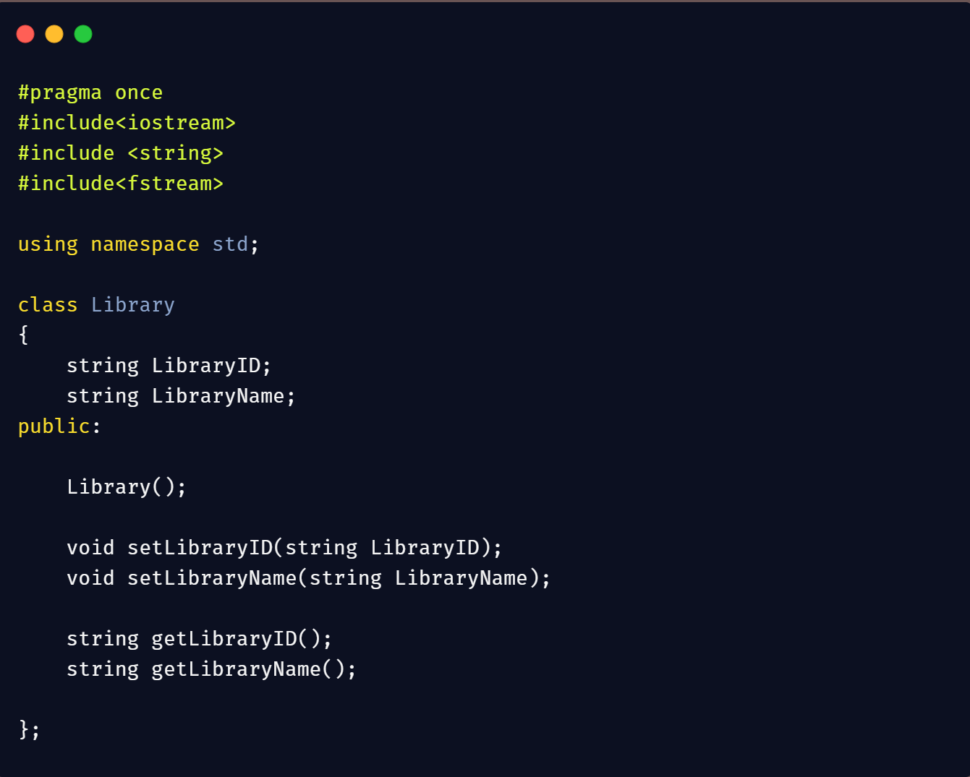

This is the **beginning** of our project and also **base/main** class of our project which serves as a **backbone** in our product. It’s a definition of class name **Library** in a header file name **Library.h** designed by Umar Farooq (2019-CS-27). He include three **predefined libraries** in it <iostream> to use **predefined data types** like int, float, bool, double, <string> to deal with **standard strings of C++** and it also enable us to use string’s **built-in** functions and <fstream> to **deal with files** for **reading** data from files and **writing** data in the files. Class contains two **private** data members **Library Id** and **Library Name** to store **name** of library and it’s **Id**. It also contains declaration of five **public methods:** a default **constructor**, two **setter** functions and two **getter** functions. The purpose of that functions are explained below.

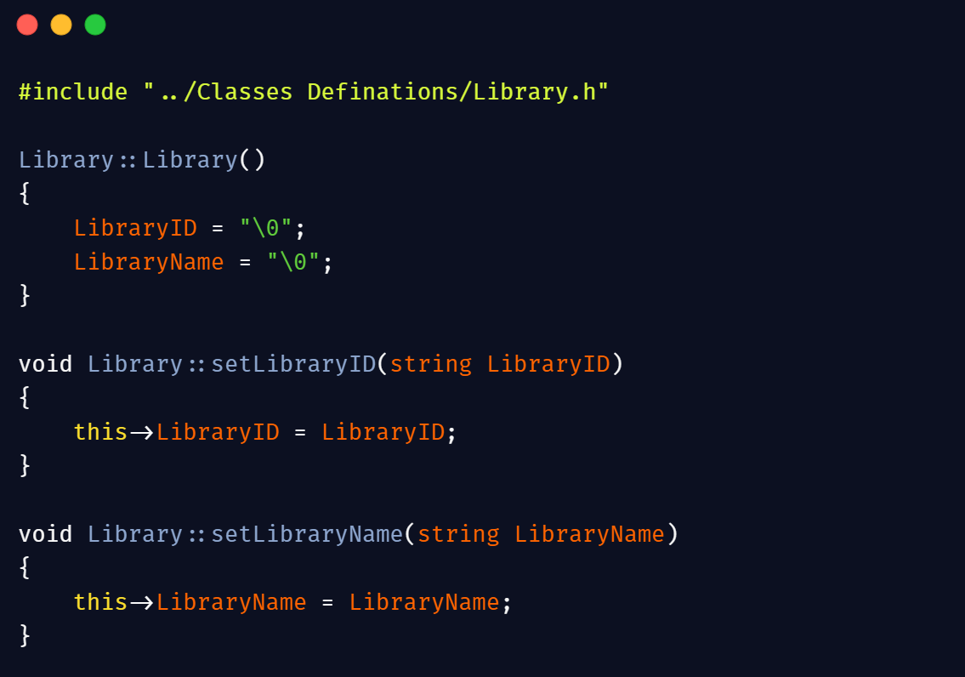

In this snippet, the definitions of functions of class Library mentioned. In first line we include Class definition of Library which is in Library.h file. We use class name Library with scope resolution operator ( **Library::** ) to tell the linker that it’s a member of class Library. The first definition is the function definition of Default constructor which simply initialize the data members with null values to optimize them and to avoid function garbage values. The next two definitions are setter functions definitions which is used to set the values of data members coming from objects. The **this** **keyword** used here to tell the linker that the parameter’s value stored in data member of the class and void keyword ensures that function returns nothing.

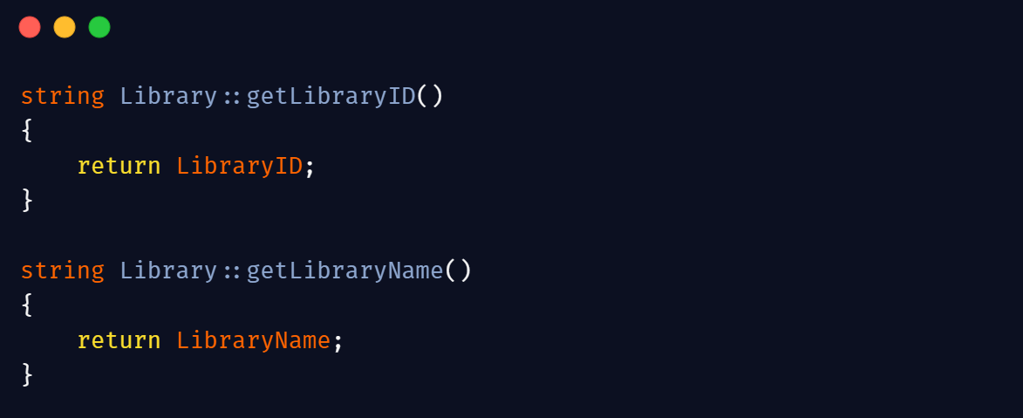

This part contains the getter functions definition of class Library. Getter function are used to get the values of data members set through setter functions because we have no right to access the data members directly and mutate its value to set the value of data members setter function used and to get this value getter functions are used and return type of getter functions are same as the data type of data members in this case both data members data type is string so return type of getter functions are string too.

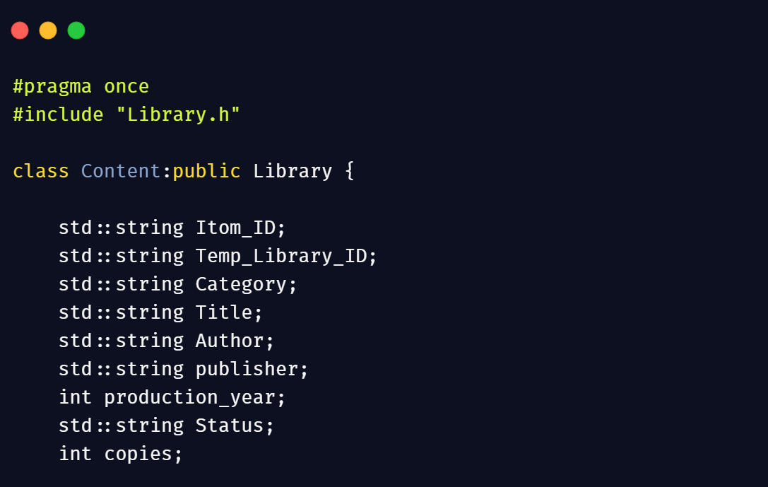

This is a **sub class** of main class Library named **Content/item** designed by Muhammad Ameer Baksh **(2019-CS-28)** which is used to deal with the **specs** of an items in our **product** and here we implement **inheritance** and inherit the class library **publicly**. The **std::** before strings is a

common practice used by developers. You can get rid of this by including **std** as **namespace** at the top.

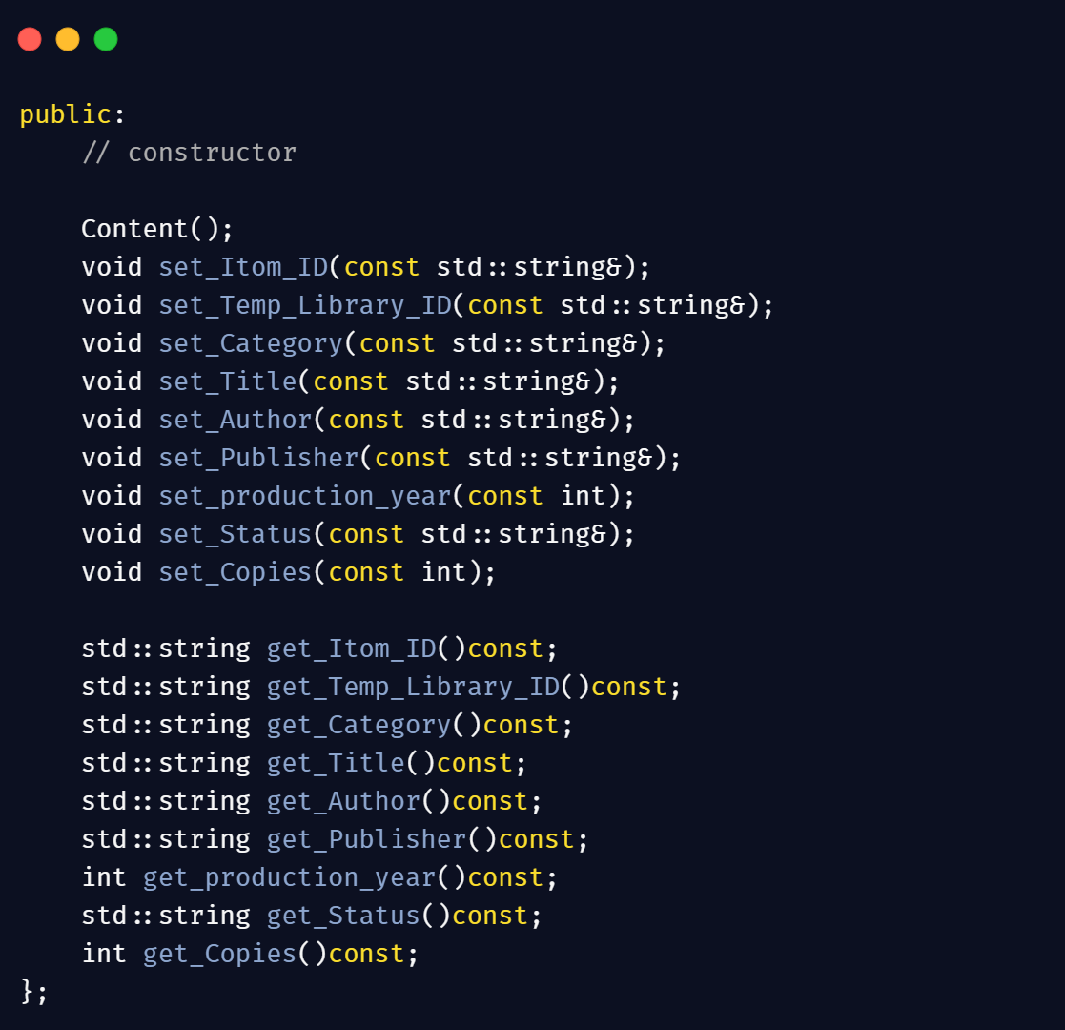

Here is the snapshot of the remaining class body which includes setter and getter functions of the class declared publicly and their bodies are in Content.cpp file. He use **const** in getter functions to secure returning data and ensure it no one can mutate or change data.

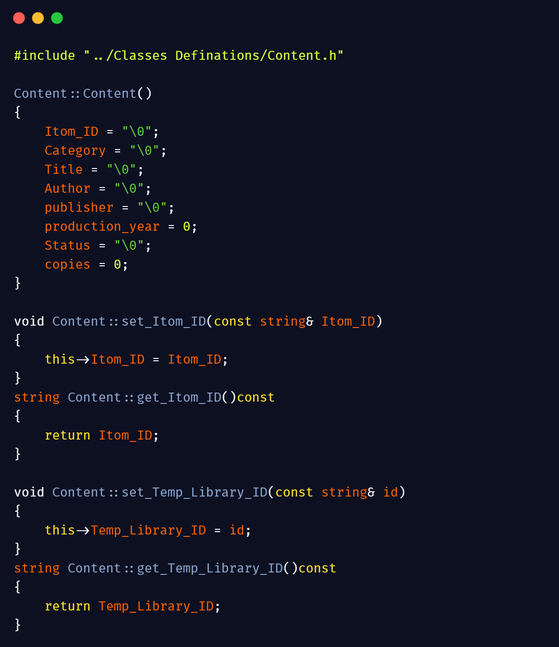

Here’s the snapshot of the Content.cpp file which contains the definition of class methods. This screen shot contain definition of default constructor which initialize all data members with a null value, definition of setter function for item’s id to set its value and getter function of item id to return the settled value of the member. It also contains the definition of setter and getter functions for member tempLibraryId which is used to assist storing of data.

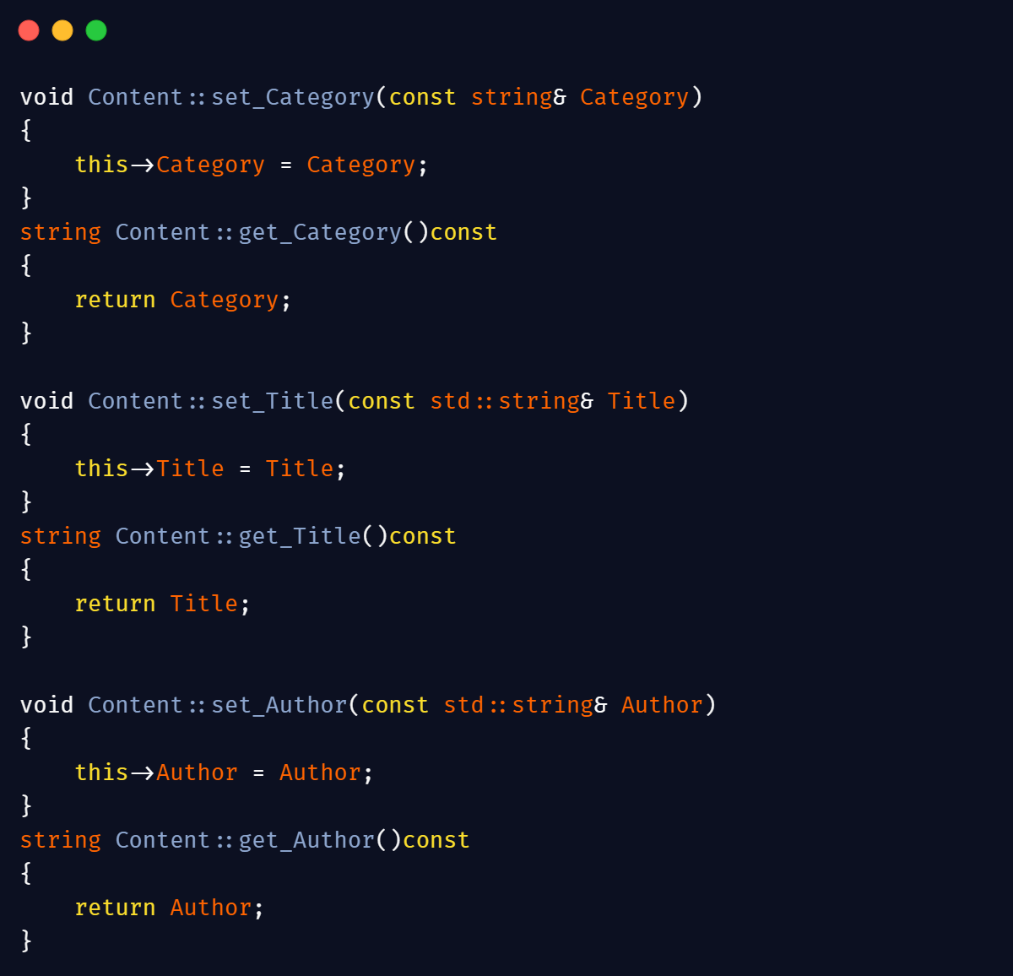

This snapshot is the remaining part of the Content.cpp class. It contains the definition of setter and getter functions of the data members: Title, Author and item’s Category.

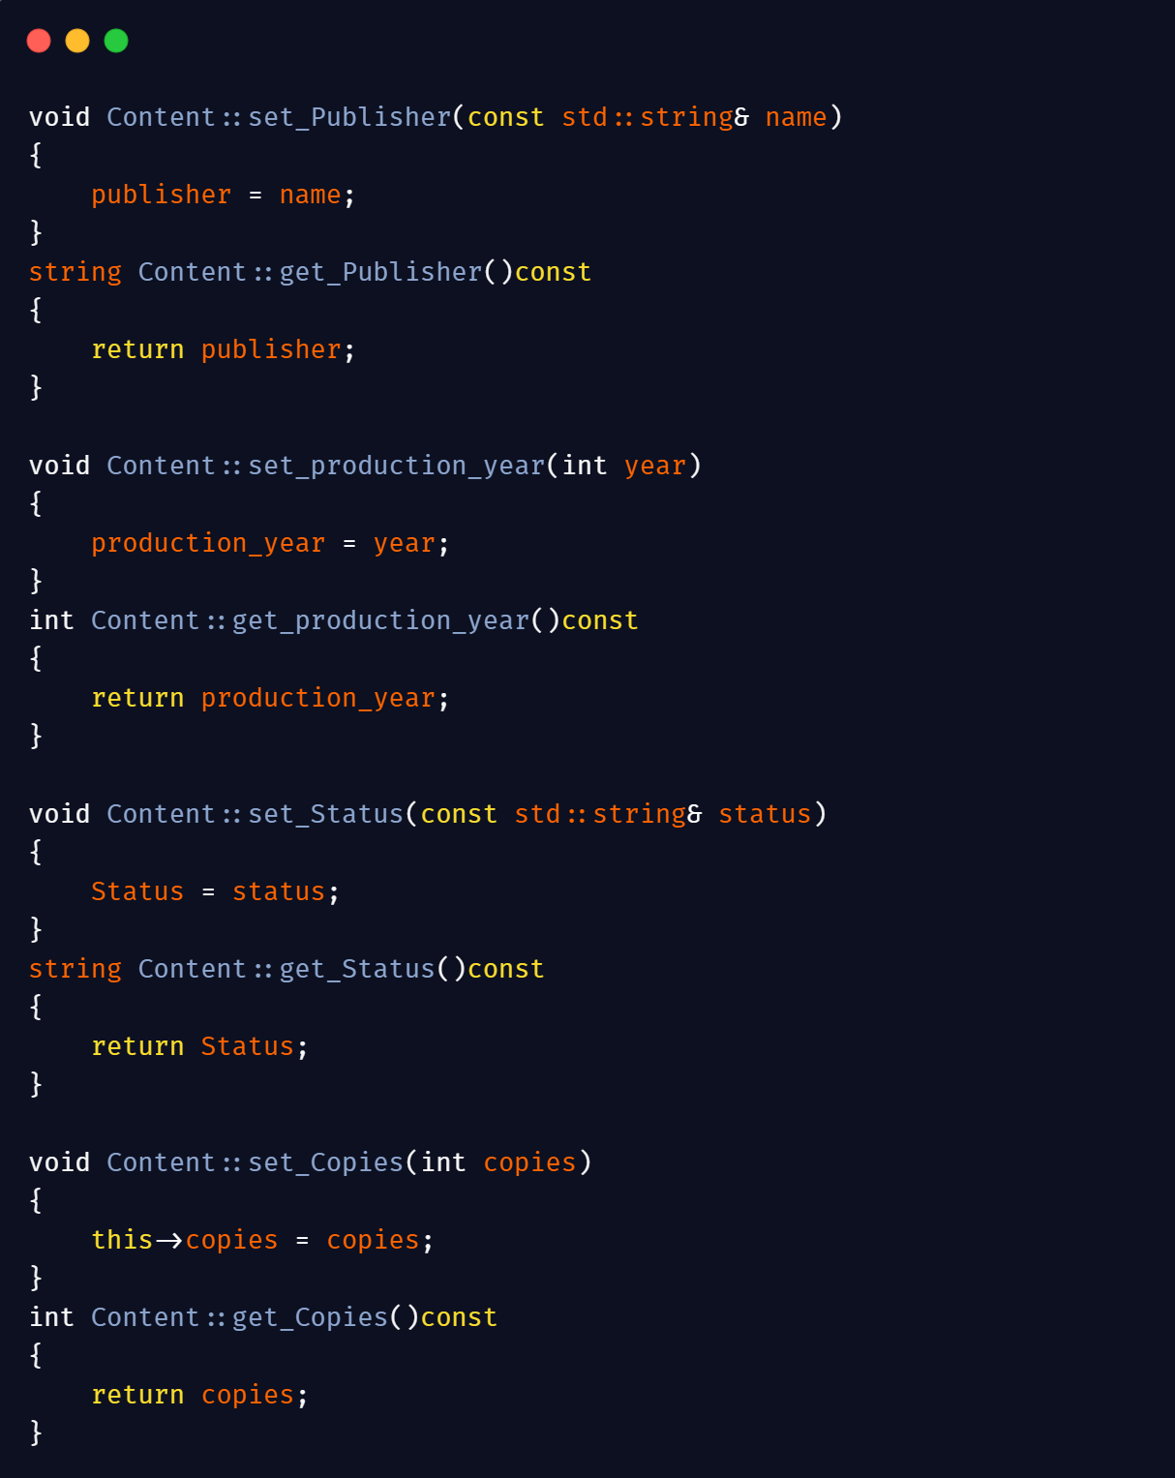

This snapshot is the last part of Content.cpp file. It contains the definition of remaining setter and getter functions of data members: Publisher’s Name, Production Year which is the publishing year of the item, Status and number of years.

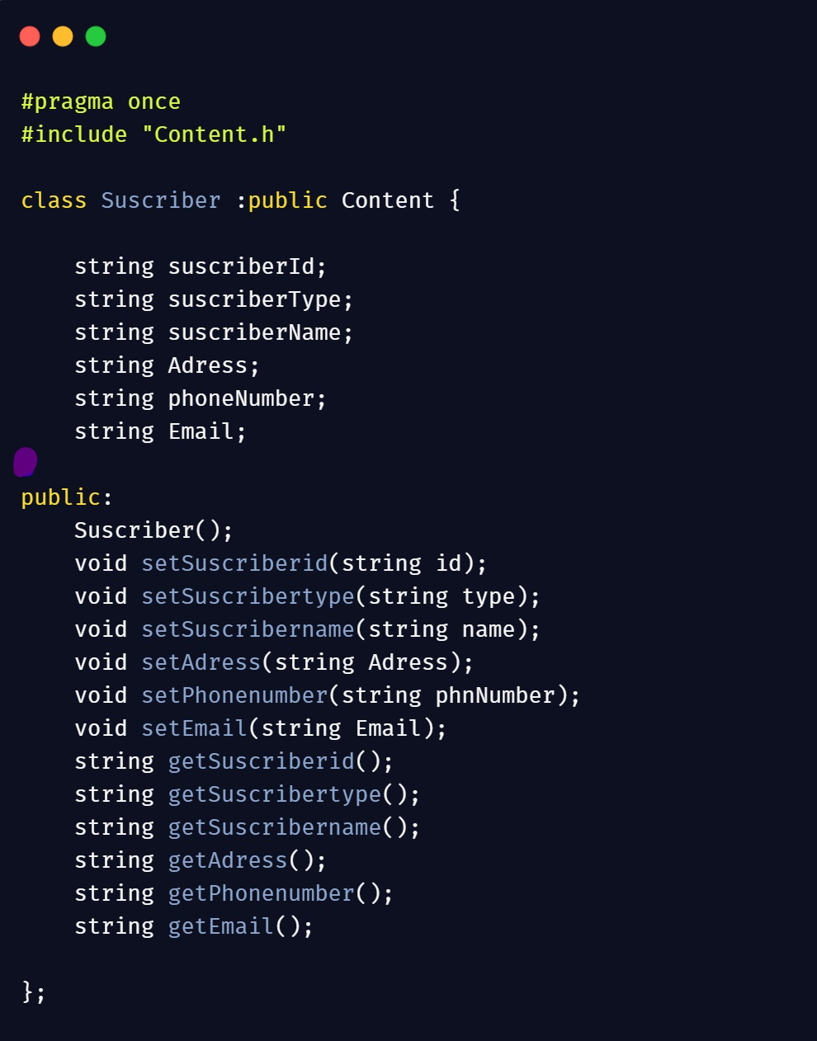

It’s a snapshot of the class Subscriber designed by Hassan Wasti **(2019-CS-40).** It contains the data members which holds the information of Subscriber when he/she registered and declaration of getter and setter functions of this class and located in file Subscriber.h and this class is a sub class of Content.

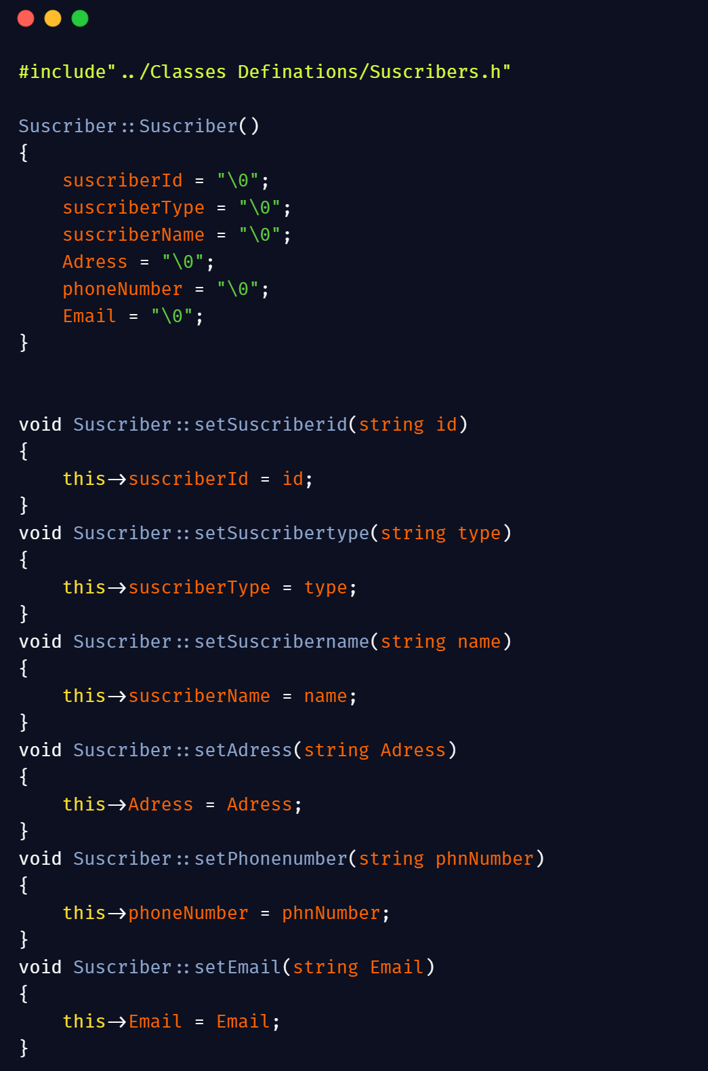

Here’s the snapshot of file Subscriber.cpp which contains the definitions of all setter and getters functions. This snapshot contains definition of Constructor and setter functions of data members: SubscriberId, SubscriberType, SubscriberName, SubscriberAddress, PhoneNumber and Email of the Subscriber.

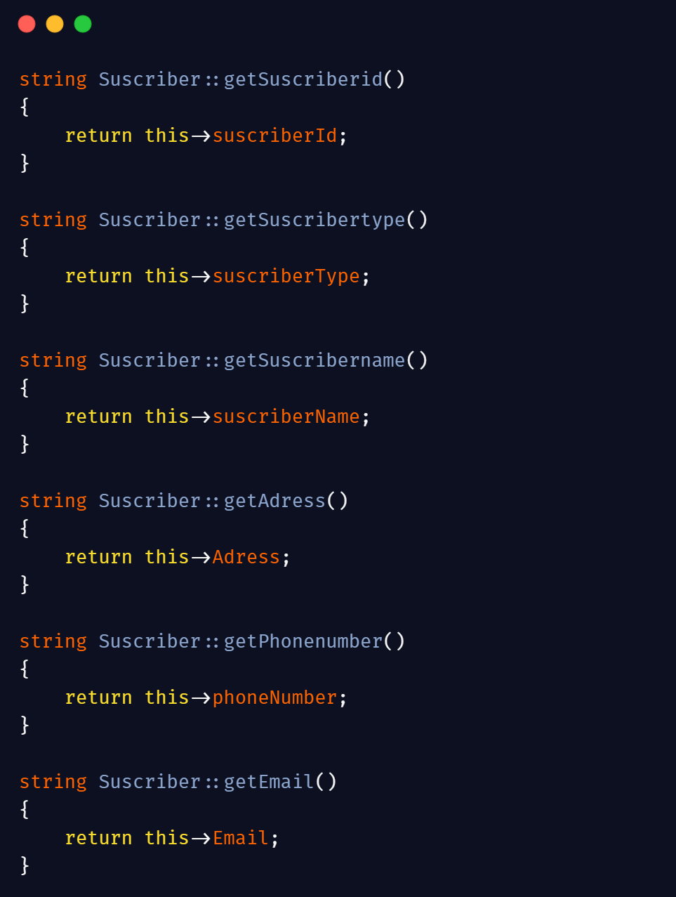

This snapshot contains the remaining part of the file Subscriber.cpp. It contains the definition of getter functions of data members: SubscriberId, SubscriberType, SubscriberName, SubscriberAddress, PhoneNumber and Email of the Subscriber.

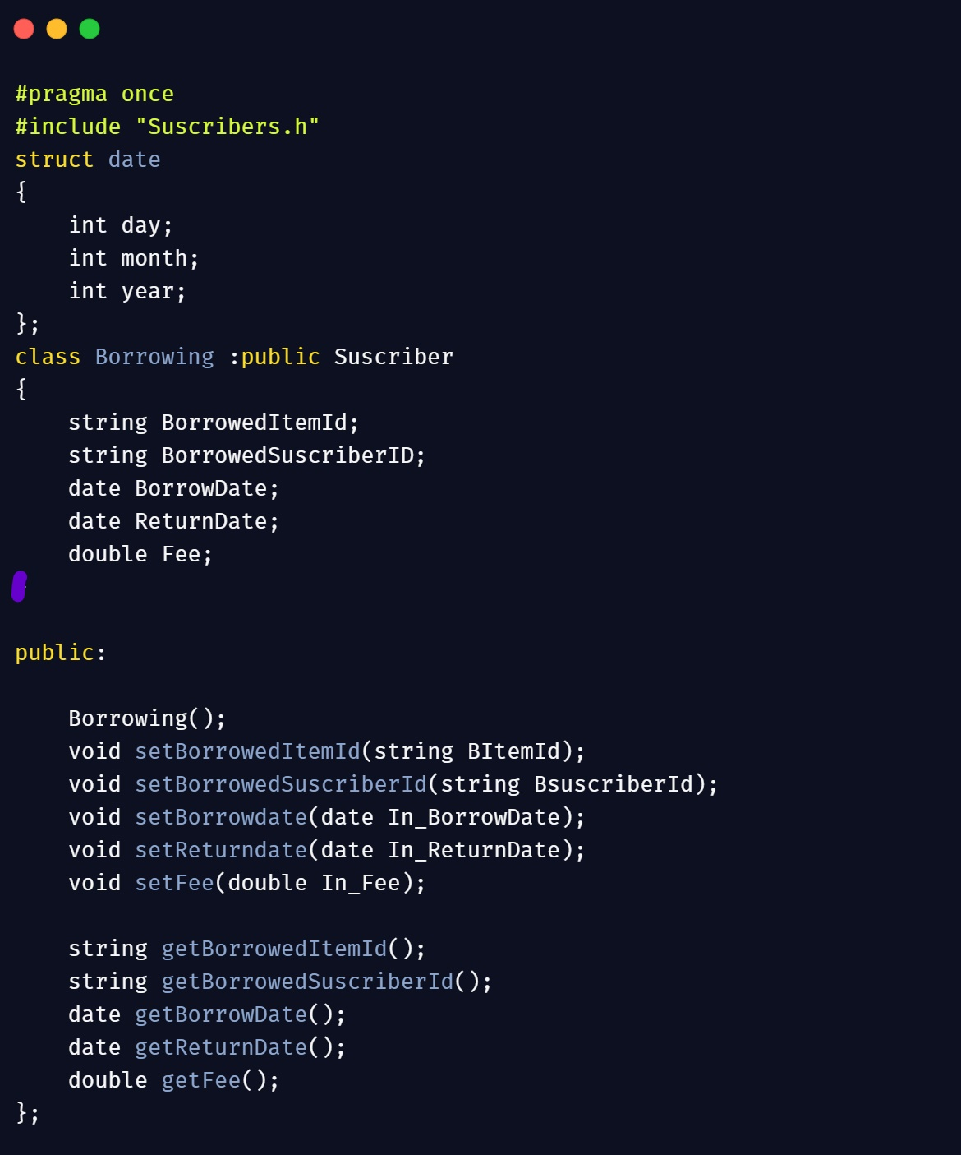

Here’s the **snapshot** of class **borrowing** designed by Maimoon Ahmad **(2019-CS-42)** which is used in case if someone wants to borrow an item in our product. It’s located in file Borrowing.h and contains the data members to hold data and member functions declarations. It also contain a structure name date to get the current date used for fine purposes. This class is a sub class of inherit class Subscribers.

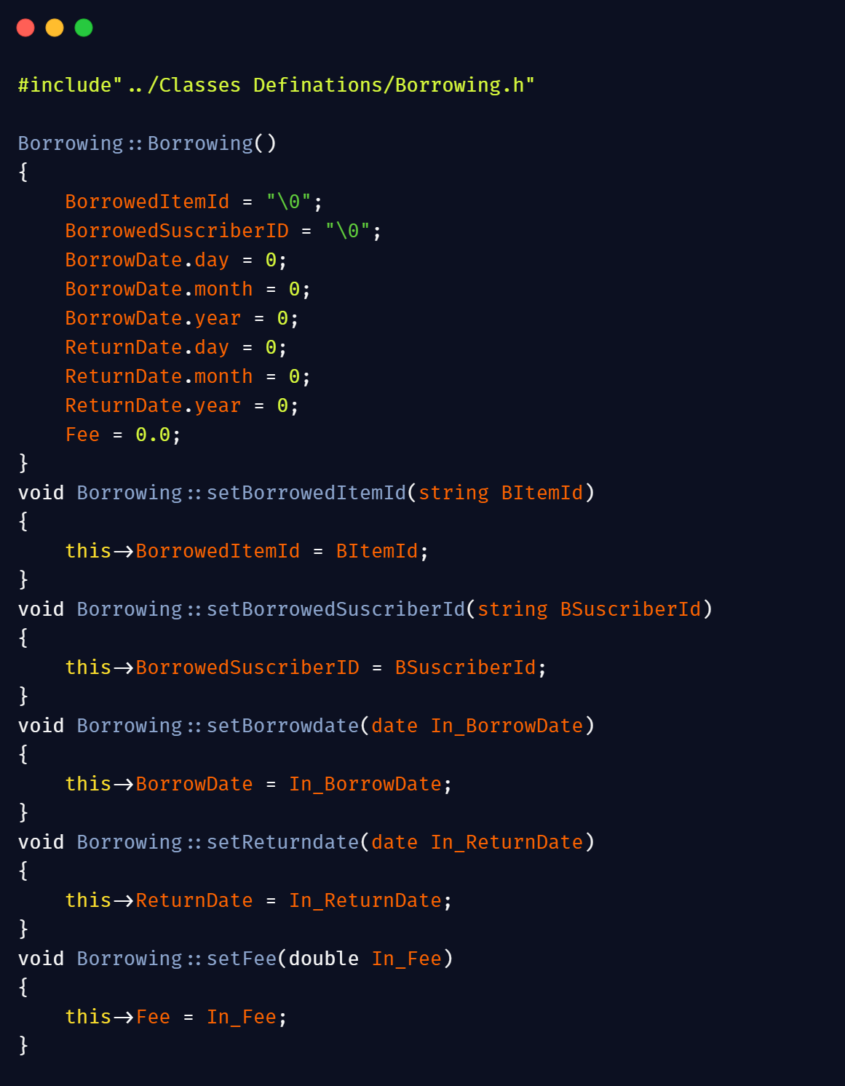

Here’s the snapshot of file Borrowing.cpp which contains the definitions of all setter and getters functions. This snapshot contains definition of Constructor and setter functions of data members: BorrowedItemId, BorrowedSubscriberName, BorrowedDate of the item, ReturnDate of the item and fee/fine on the user who returns an item late.

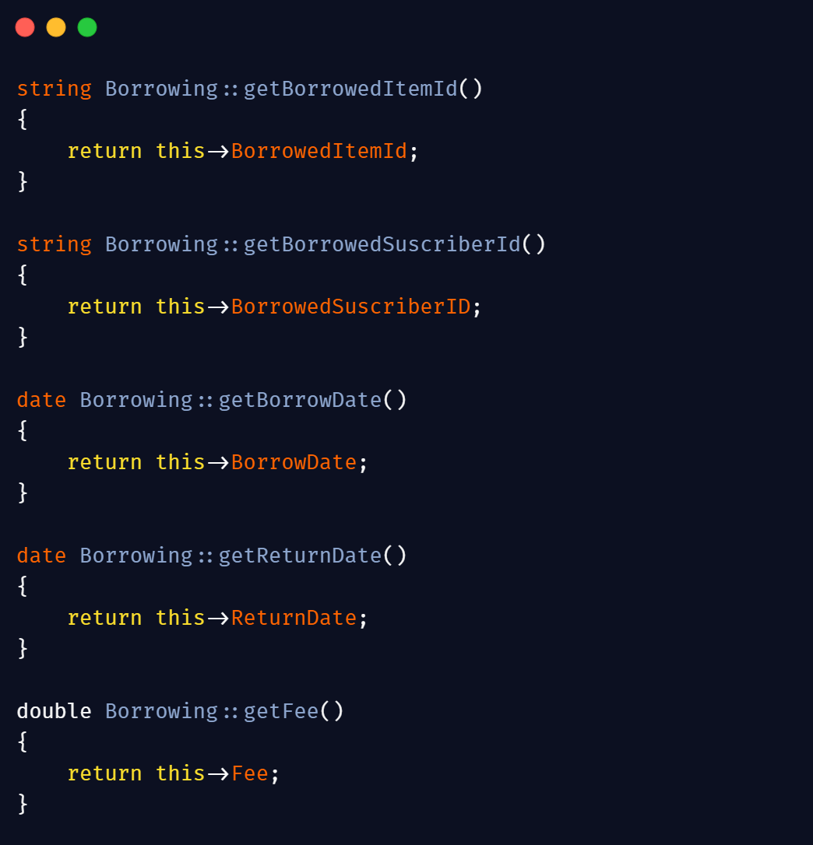

This snapshot contains the remaining part of the file Subscriber.cpp. It contains the definition of getter functions of data members: BorrowedItemId, BorrowedSubscriberName, BorrowedDate of the item, ReturnDate of the item and fee/fine in case of late return. If you notice on the return type of BorrowedDate and RetrunDate getters it’s a user defined type date which means it returns an object of type date which is defined in the form of a struct in file Borrowing.h.

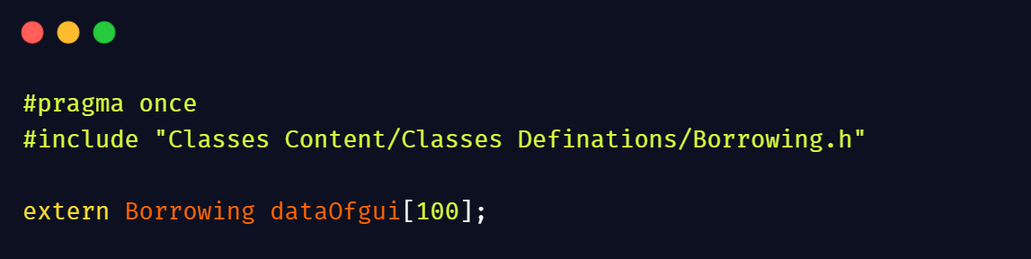

As we design all classes the next step is to declare a class object to use the content of that class. As we implement multilevel inheritance so, we are able to use attributes of all classes by a single object of last class. So, in the given snapshot we declare an object array of class Borrowing which are able to use the attributes of all classes we make it, an external variable so it become portable and we are able to use it in anywhere in our project by simply including header file objDecfile.h in which this object is defined. The keyword extern also tells the linker that the following object define only once and if we don’t use the keyword extern it will throw the below mentioned error and we are unable to use that object in our code because linker is unable to identify it as an external object.

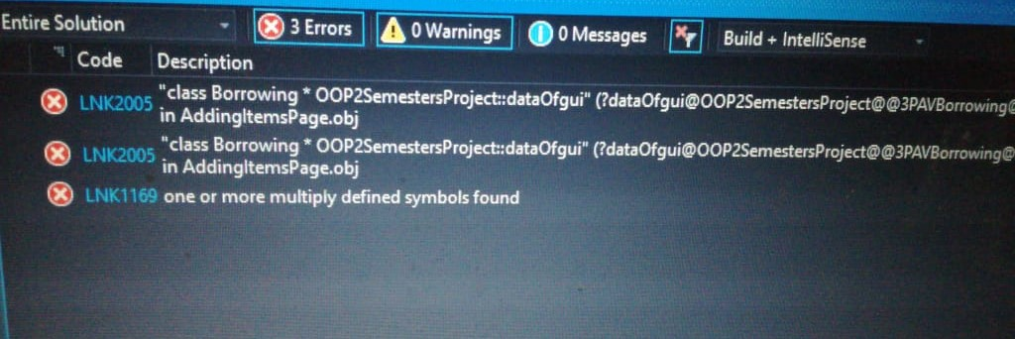

As we define this array dataOfgui[100] now it’s the time to declare it for this purpose we are supposed to make a separate .cpp file. In our case the name of this file is objDecfile.cpp and we can declare this array in the file by the method showed in the below snapshot.

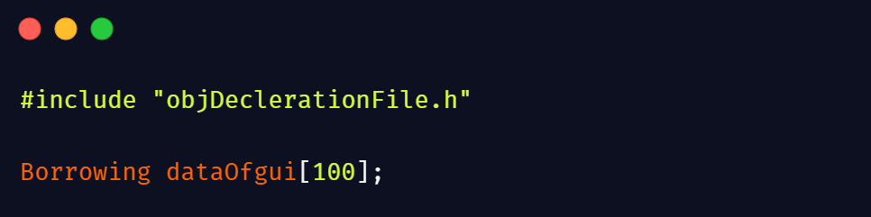

If you notice the declaration of the object is same as the definition of the object excluding the keyword extern which tells the linker it’s a declaration of that object not a definition and if we don’t declare our object then the compiler will through below mentioned error.

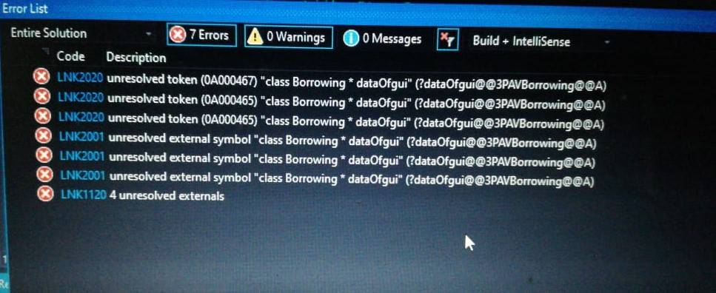

We design our classes, declare an object to use their attributes, as all things set now it’s the time to integrate our classes’ code with our GUI code. For this purpose, we include header file objDecfile.h in our forms header file where we want to use our object. As our GUI first page or starting page is MainPage so let’s move to the coding part of that page.

**GUI Integration Part**

A feature of a good product is to enable its user to use previously stored data or previous credentials of the user. For this purpose, file handling comes into the picture we can read previously stored data form files. As our main data consist of four classes so to read data of that classes we make four functions named loadDataofLibrary, loadDataofItems, loadDataofSubscribers, loadDataofBorrowing. The snapshot of that functions are given below

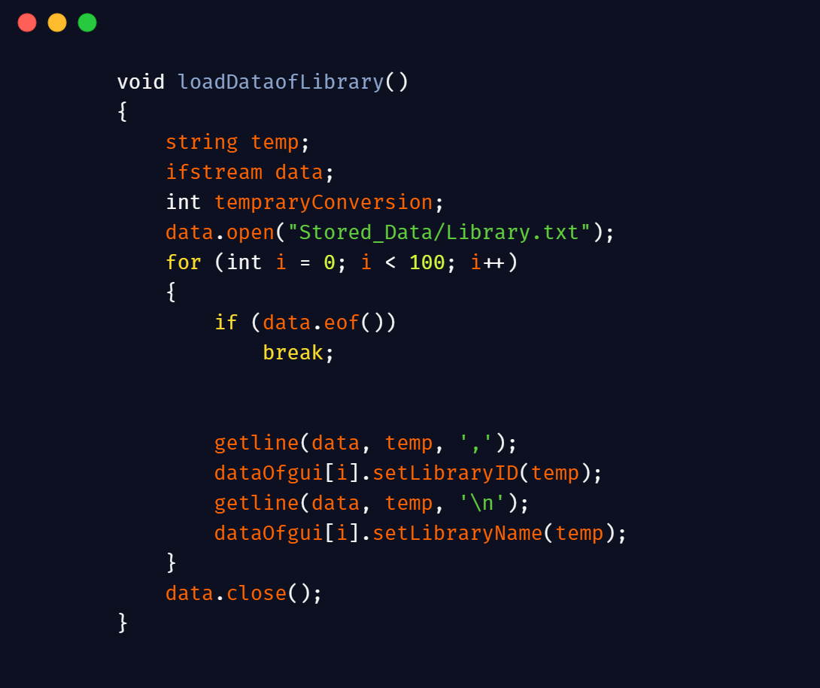

In this snapshot of loadDataofLibrary is defined which we used to load data of Library related content like library name and Id. We declare an input file stream pointer name data to open file input stream of the given file ‘Library.txt’ and temporary string variable name temp in which we store data coming from file and set it as the data member value through setter functions. As we store **,** between two values to differentiate it with one another during storing process so, we give **,** as the third parameter to the getline function to differentiate it with one one other during time of reading to ensure that right data load on temp and also place a new line character ‘\n’ in the second getline to read data until the end of line in a file. After loading this data in the variable temp we simply use setter functions which we access through object array dataOfgui to set the right value on right member. We also use **eof** which tells that nothing left behind in file for reading and return a true signal. Here, we use eof as when nothing left behind in file it simply breaks the loop and protect members for setting of garbage data and when it completes reading from the file it simply close the file using .close() function.

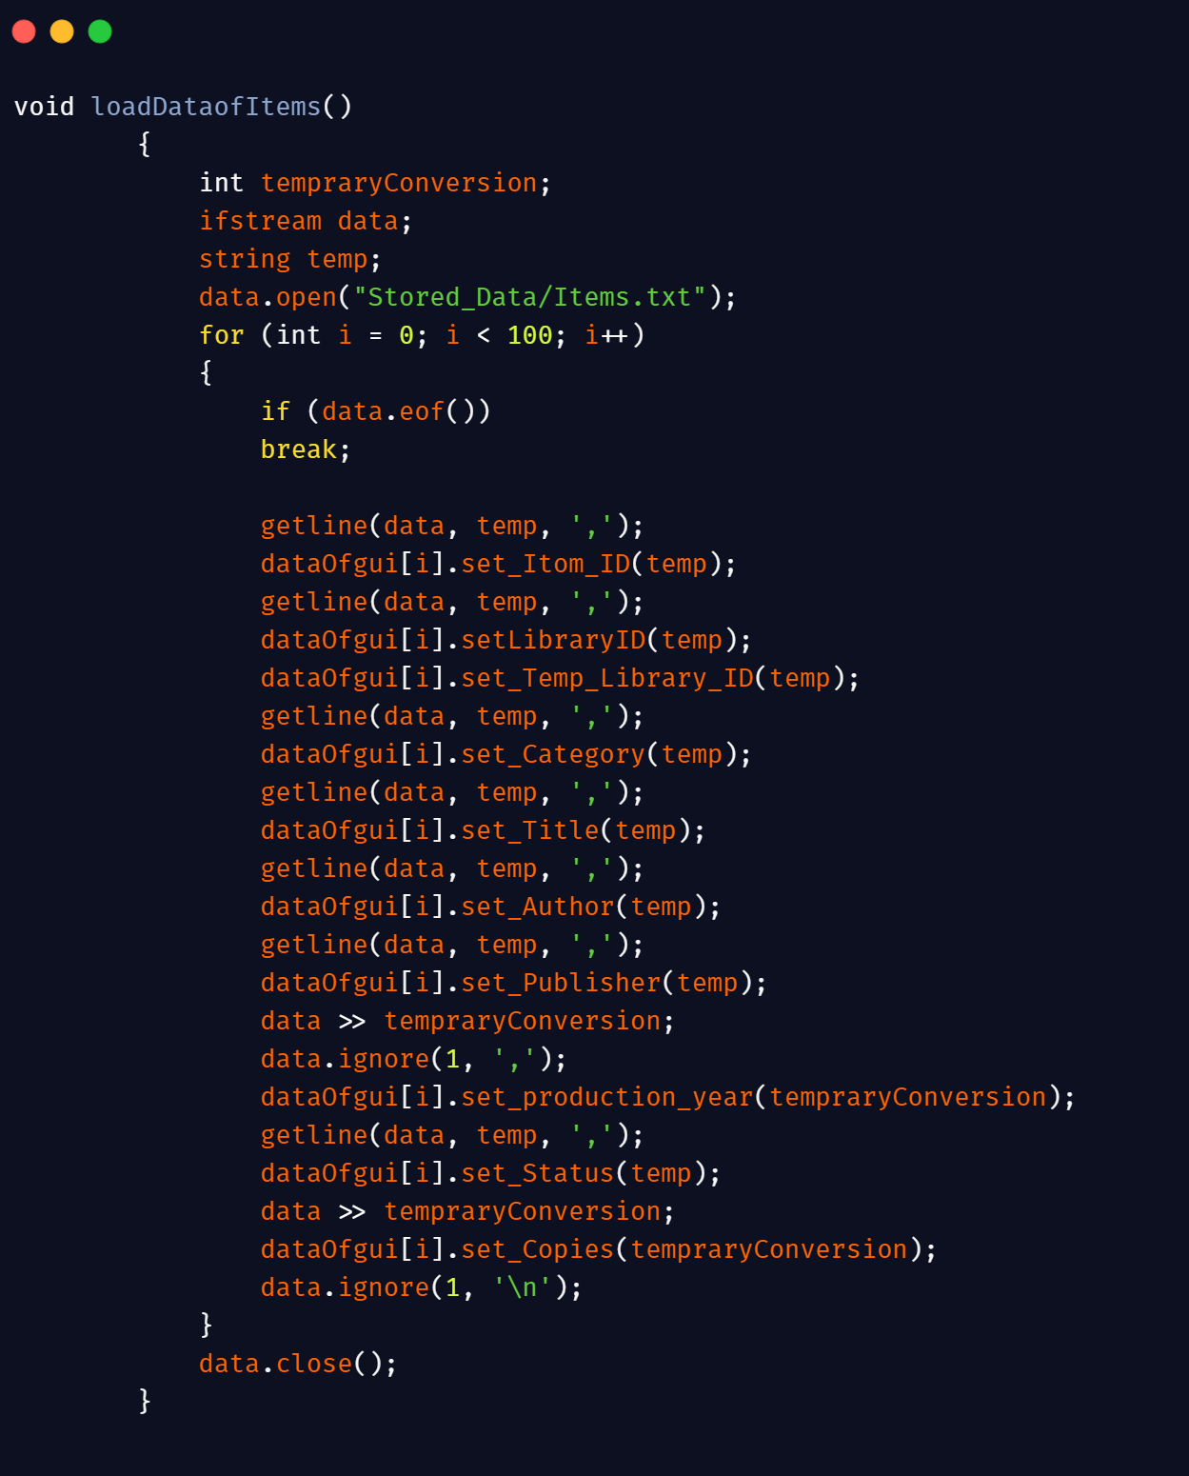

In LoadDataofItems, the working of the functions is as same as the working of the previous function only a mere twist here is that some data members of this class are of other data type then string so if we use getline to read data it will through an error. Here we can follow two approaches: First, we can store data in the form of string using to_string function and then read it through getline and store it in data member by converting it in integer using stoi() function but it has a limitation stoi couldn’t work in a loop and it will through a runtime error. Second: we can declare a temporary integer variable and read data in it and pass as a parameter of setter function but it also has a limitation. When we read data using extraction operator **>>** it’s unable to identify from where to where we want to read data, to solve this problem we can use ignore function with the separator as **shown in snapshot** it tells that read until this character comes.

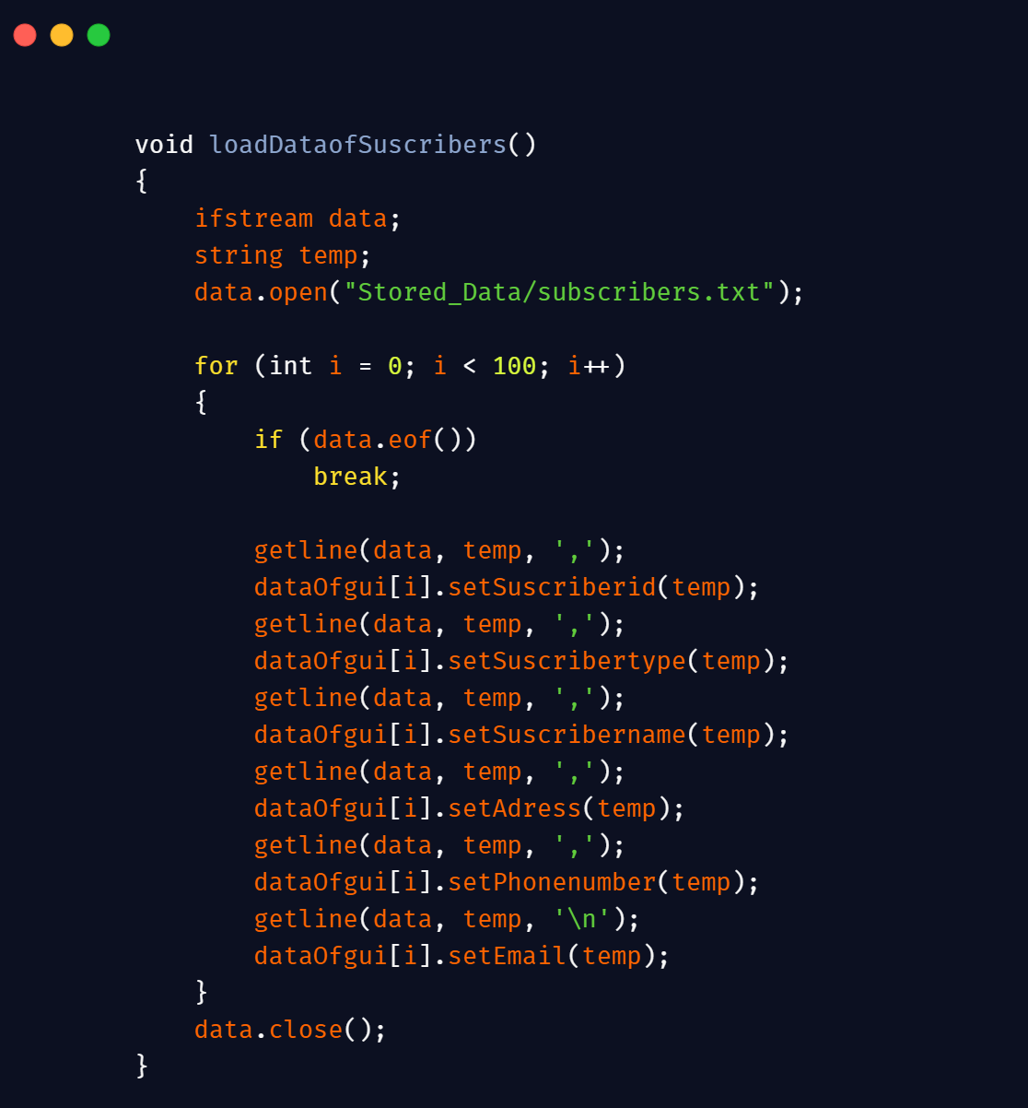

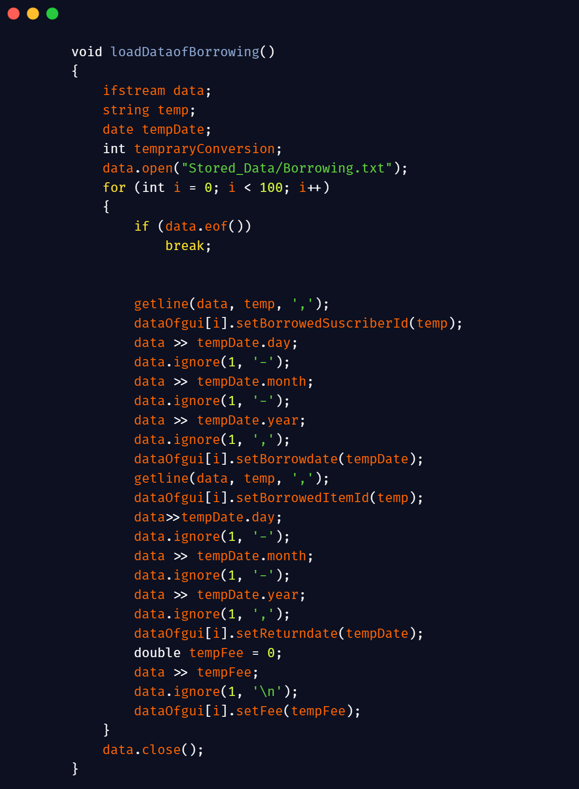

The both functions loadDataofSusbscriber and loadDataofborrowing has same working as mentioned in the previous two snapshots of the functions.

Now we come to the part, where we make GUI design functional through backend coding of the GUI by binding its buttons. As our Main Page contains four options Login as an Admin, Login as a Subscriber, Register as a Subscriber here we come to admin part. The following snapshot of code tells how Admin login page appear after pressing login as an Admin.

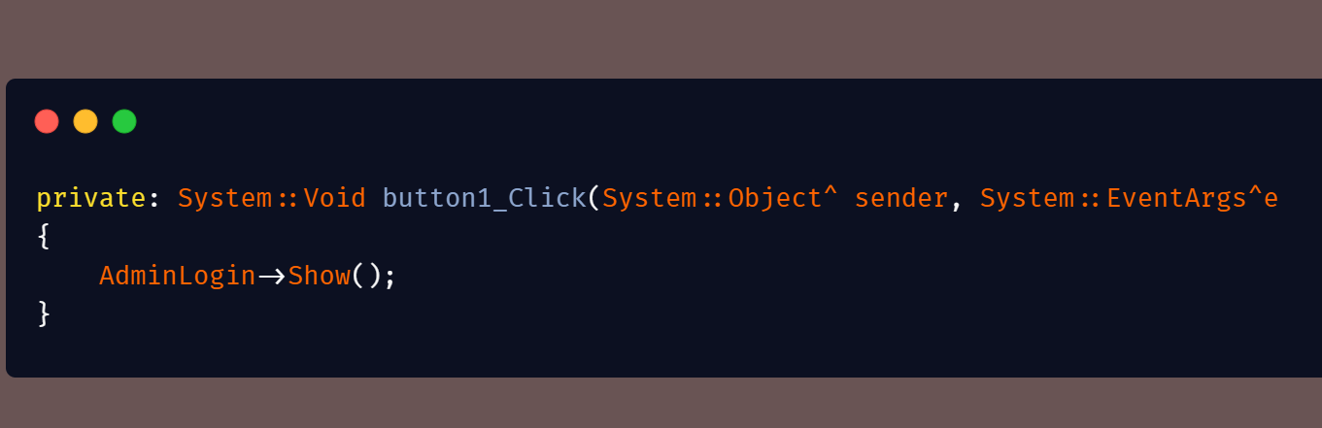

AdminLogin is basically a panel we created on the Main Page form when user press Login as an Admin, Show() which is a built in function shows the pa nel which we hide explicitly through Hide() function in the constructor of Main Page and this panel cover our main options page and ask admin to enter his password for further proceedings. The snapshot of code behind Admin login Page is below:

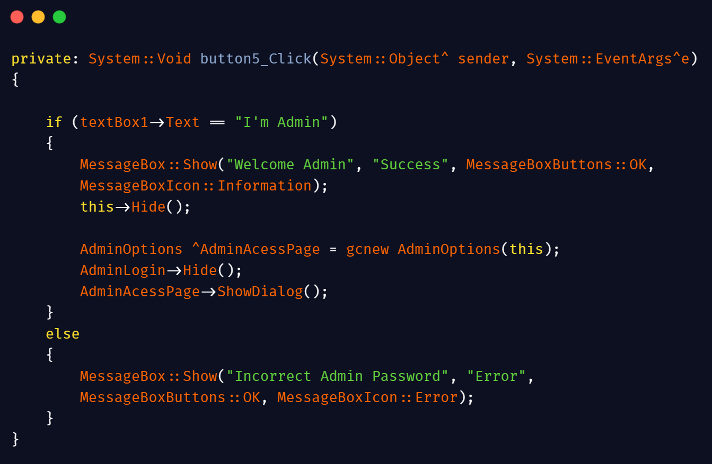

In this snapshot, private:System::Voidbutton5_Click(System::Object^sender is the event function which invokes when button is pressed. We can figure out from this, when the button is pressed the value which is coming from input field and access through textbox->Text, matches from the preset password ‘I’m Admin’ and if the value is not equal to preset password it simply display an error message through MessageBox which is a built in function of windows forms and use to display small messages and if the value is matched to the preset password it display a success message and then this form is hide using this->Hide(). ‘this’ is a keyword in C++, that refers to the current instance means here its means is current form and this->Hide() means to hide the current form. Then, in the next line we are declaring an object of the form where we want to switch using keyword gcnew which is similar to new keyword except we don’t need to use delete keyword in it and it also limited to .NET managed classes. After declaring the object of the form which referred to that form we simply make visible to this form using ShowDialog() function. Hurray! Now, you are on admin’s option page where you can access variety of options. To understand the working of code behind Admin’s option page we take a glimpse to its code.

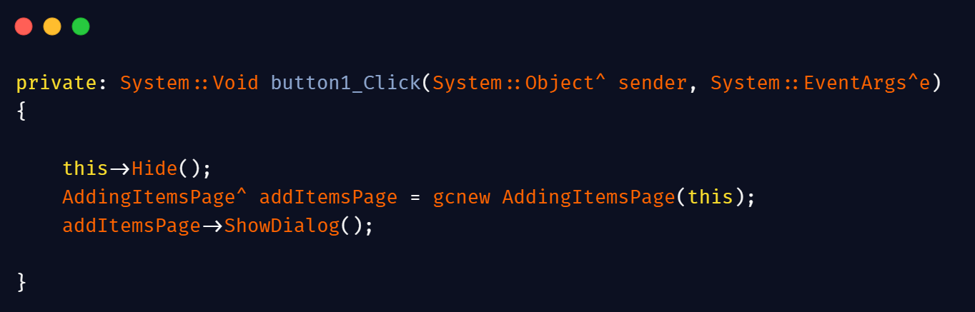

This snapshot is the backend code of button ‘Adding a new item’ and it hides this form and switch the Admin to the Adding items page, where he can add new items.

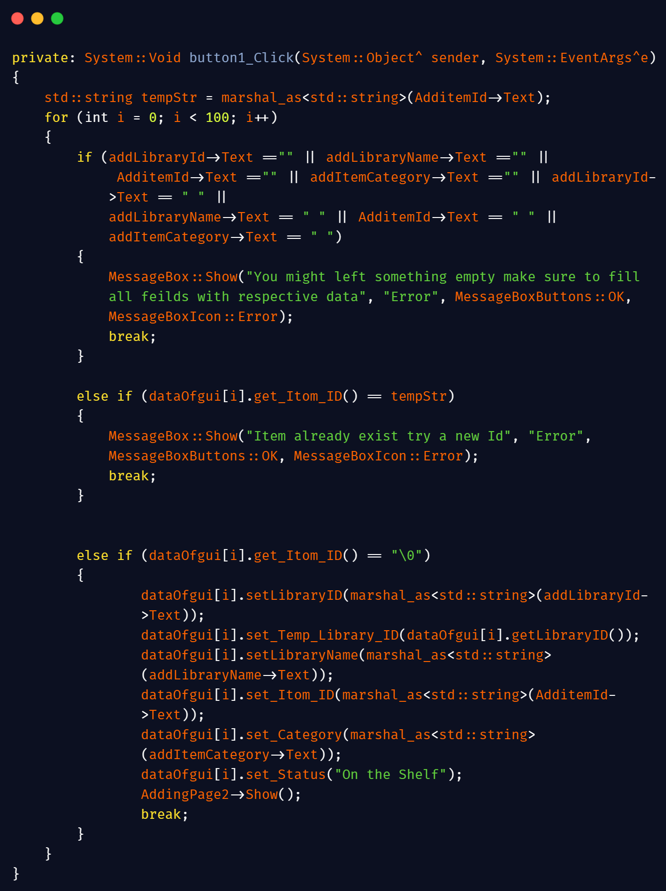

This is the backend code of the first page of the Adding an item. As we know that the data coming from input fields are in the form of system strings which we can’t use as a standard strings so first we convert it into standard strings using marshal strings conversion method as mentioned in first line which we can use by importing library #include <msclr\marshal_cppstd.h>. We store it in a standard string variable **tempStr** which we use few moments later in the code. The first condition in the loop is for validation which checks that the each field filled with data or not. If any field is empty it simply break the loop and prompt an error message which tells the user that he/she might left some field empty. The next condition is also for validation purposes which ensures Id of each item is unique and make it sure user won’t use the previous id for a new item. If user accidentally enters the previous or already exist Id it breaks the loop and simply prompt an error message which informs the user about Id. If the entered data proved previous conditions wrong now its time for storing of data. In storing part, we simply convert the field’s data which’s in the form of System Strings into C++ Standard strings and set this data to that instance of class using required setter functions and prompt a success message and break the loop to avoid overwriting or extraneous data.

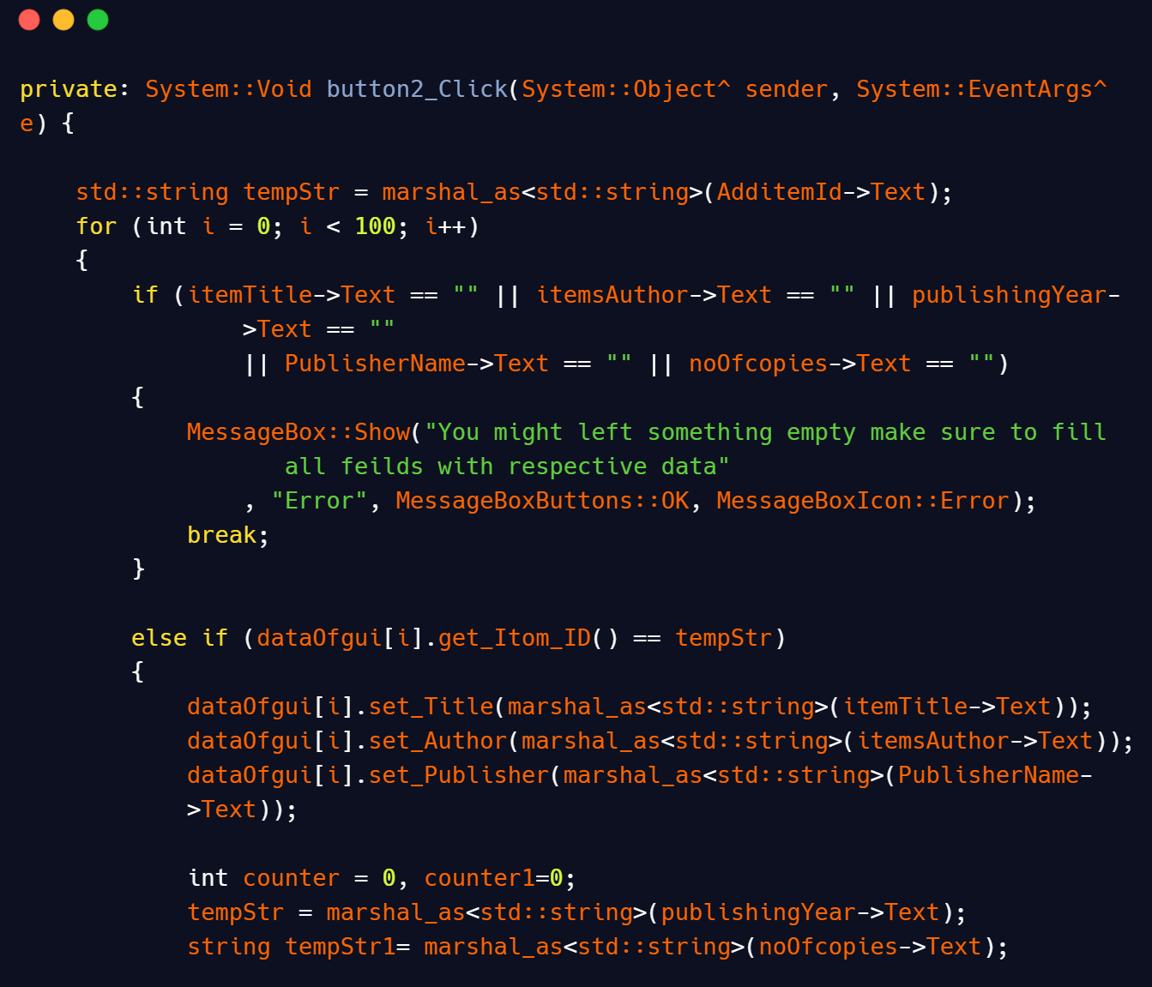

This is the code of next page of the adding item page. Here we implement the same logic as we apply on previous page for empty fields and use tempStr again to make it sure that the remaining data store on the same index of the previous page data to avoid losing of this page data. We also implement some more validations on publishing year data and number of copies of the data to make it sure that the user entered valid data. The logics of that validations are mentioned in the below snapshot.

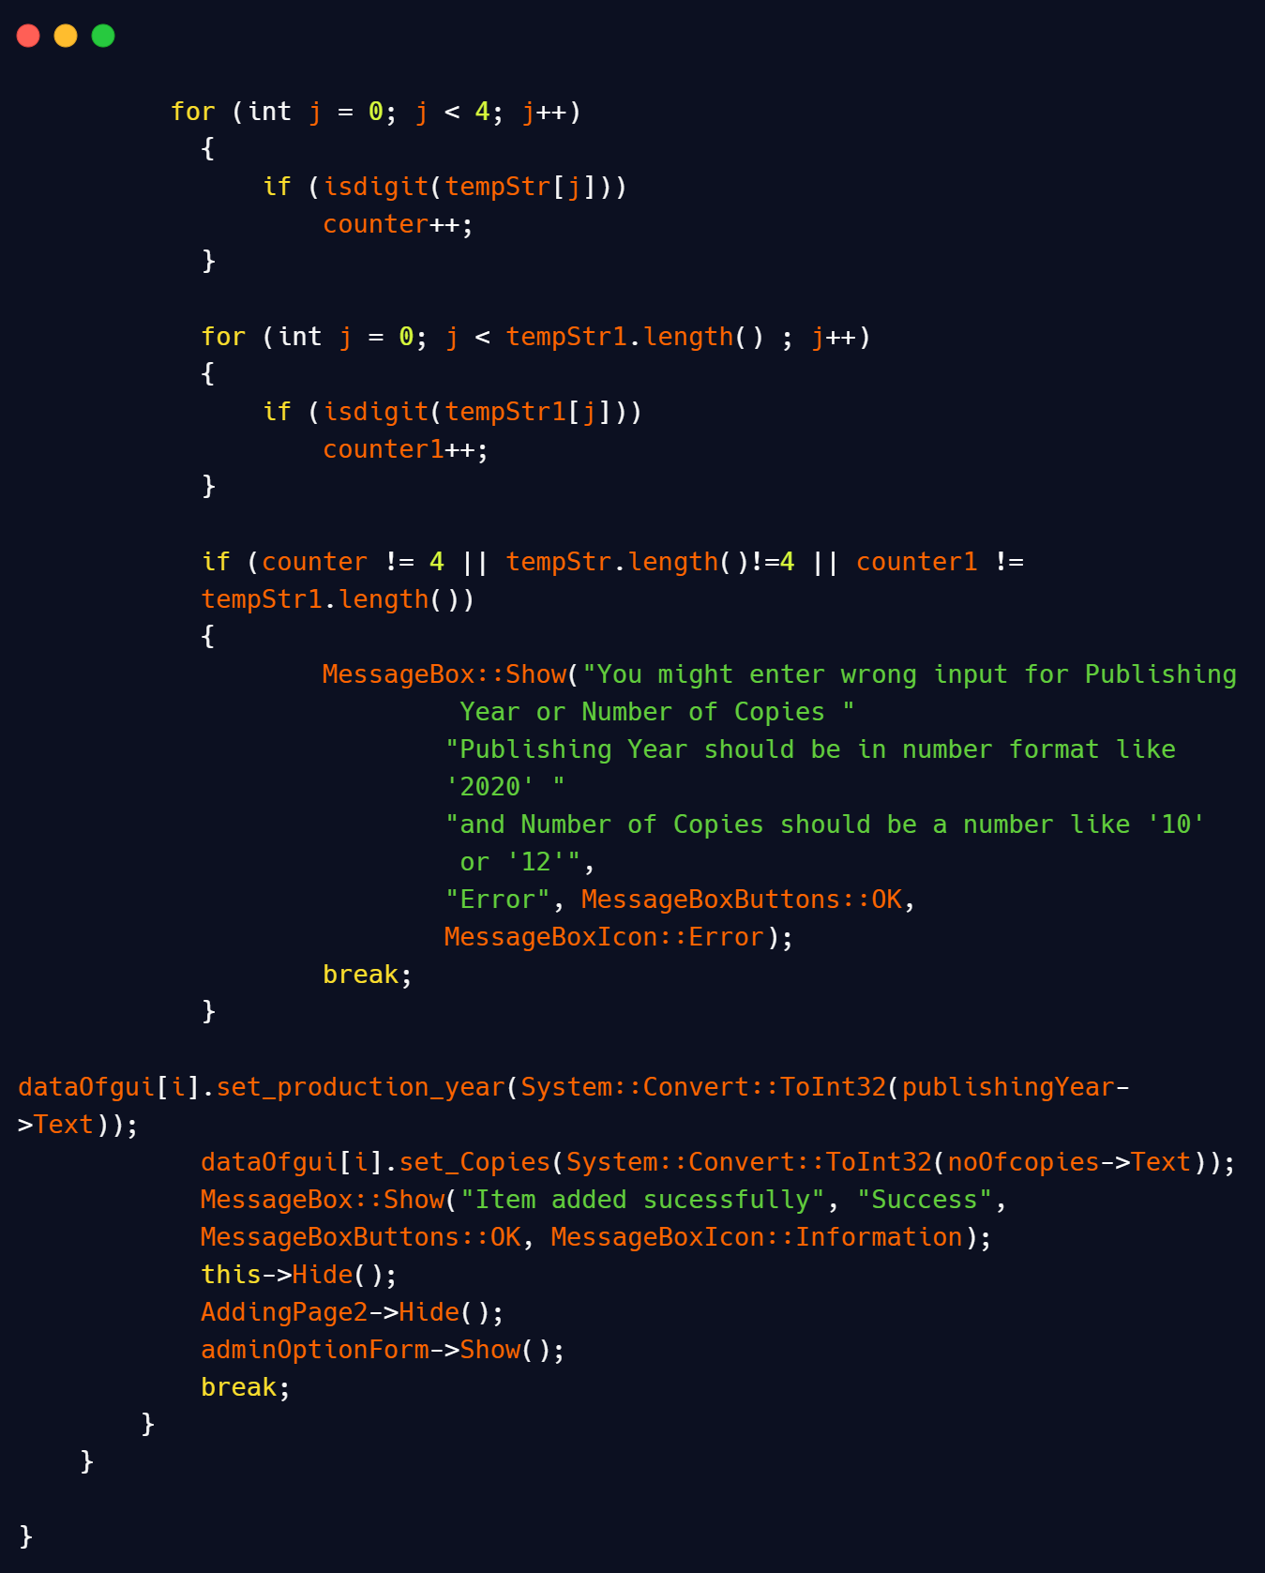

We use string length function to find the length of the string to assist our validation and isdigit function to make it sure data of publishing year and no of copies is an integer and for this purpose we use counters and make such a logic if the value of counter is less than the lengths function value it clearly symbolize user might enter wrong data so it prompt an error message that tells the user, You enter wrong data and forced user to enter valid data otherwise it simply prompt a success message and hurray a new item added in the stack ☺ and controls are shifted to previous page using this->Hide() and adminPage->Show() function. To make adminPage->Show() function functional we have to overload this forms constructor. As mentioned in the below snapshot:

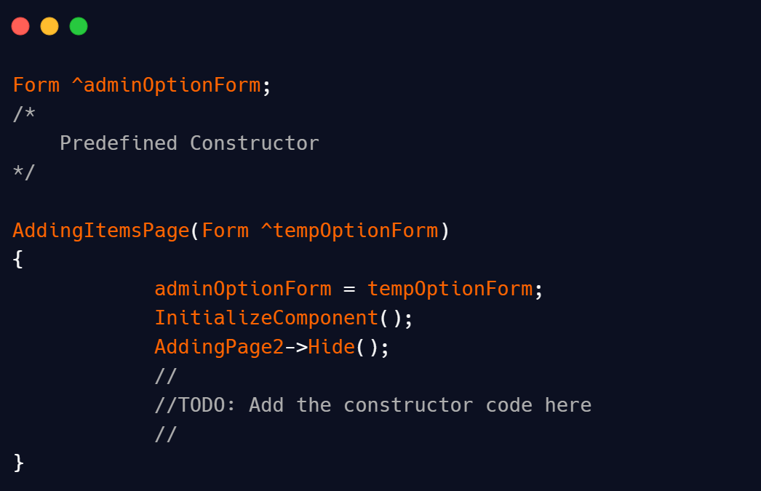

Form is a predefined class of the .Net Framework. This overload constructor actually copy the current instance of previous form from which we switch where we pass this pointer as a reference, in this variable created by Form class and at the end we show previous form by using Show() function.

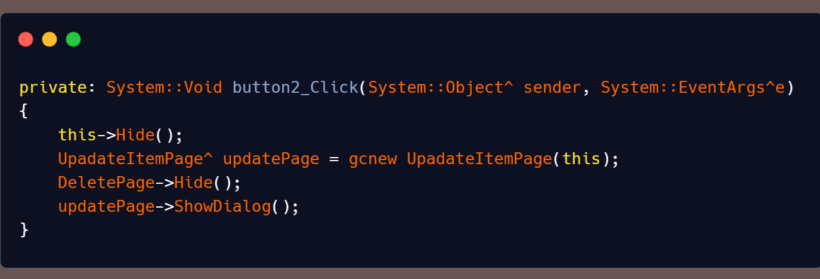

When user press Update button then following code snippet runs which switch the user to that form and the working of this snippet was explained below. Only DeletePage is a new item here which actually is a panel which we use for deleting items which we discuss later.

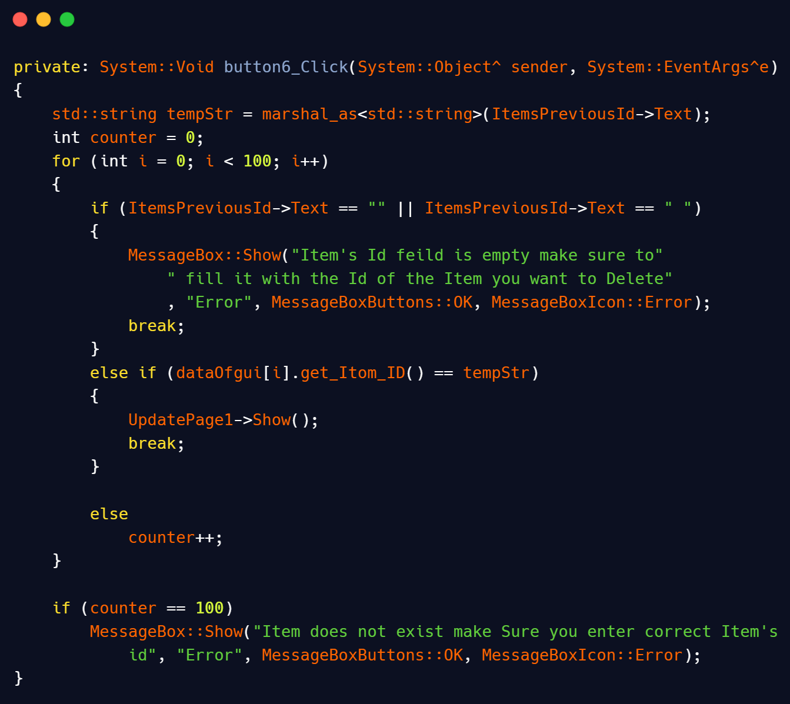

This is the code of first page of Updating an item page here user are bound to enter id of the item which he want to update. First of all, we apply the same logic to validate empty fields which we mentioned in previous snippets. In the next condition, we matched the entered Id Value with the previously stored values to make sure that the user overwrite the credentials of the item he/she want to update otherwise a value is increment on each iteration and if the value of counter is 100 which is equal to the total value which means that the entered value wasn’t match to any previous value means item of that id does not exist so it simply prompt an error message that informs user that item of such id does not exist. If the entered id match to any previous id it simply redirects user to the next page of Updating item which has same code as Adding a new item so I would not explain it here.

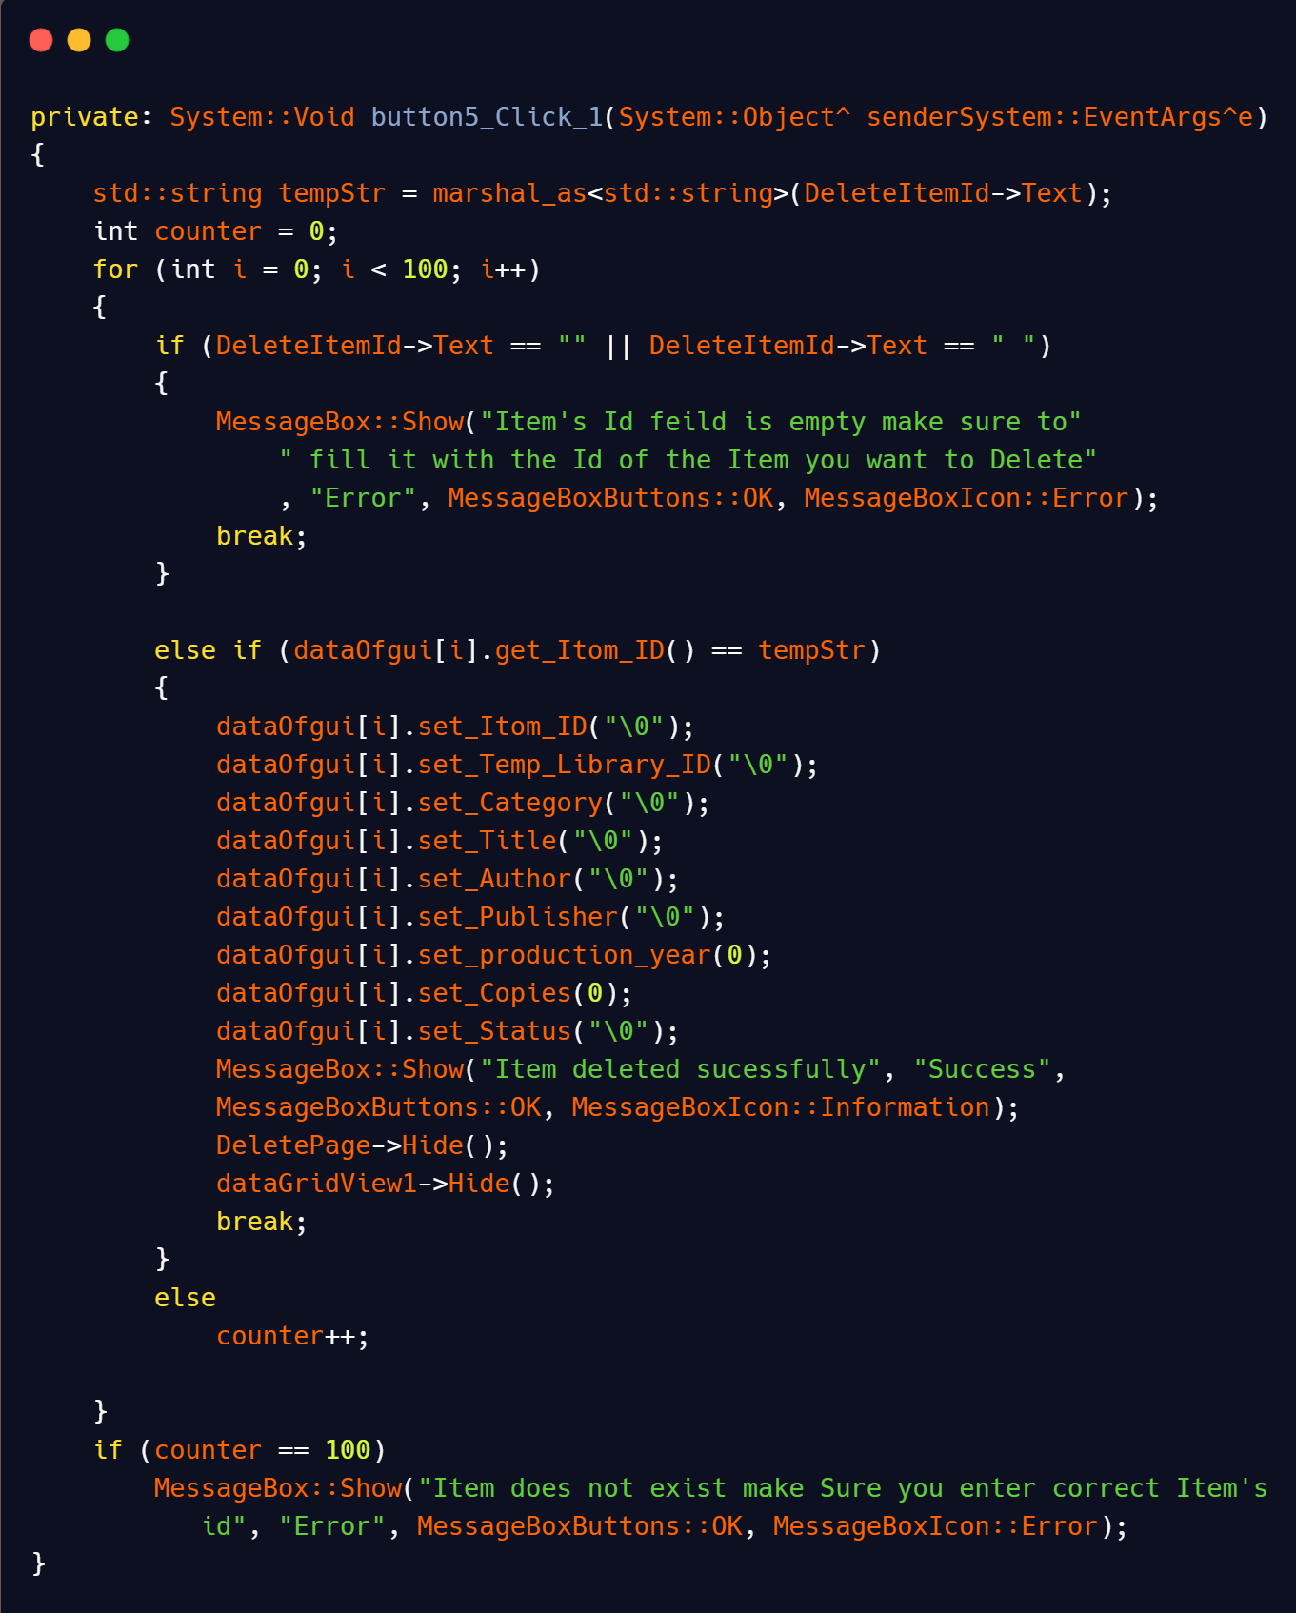

Here’s the snapshot of deleting an item’s page code. Basically, This page is a panel not a form and make it on the same page of admin option page. The working of this page is as same as the updating an item page but the only difference is that here the value is set to null values which means the item is deleted here. Datagridview is also a tool of gui use to show data in table format but we discuss it later.

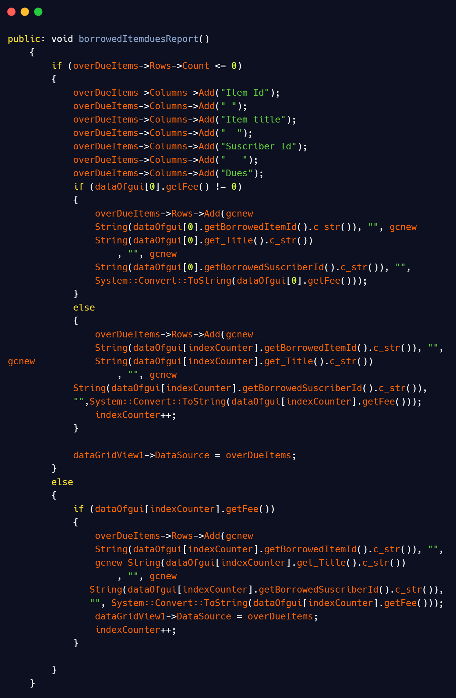

Here’s the snapshot of View overdue items code actually we are making a table like interface using Use->columns and use->Rows functions. We use Rows.Count to move it on the next conditions to avoid overwriting of previous data and use index counter variable as an index value to change the value on each calling of that function to make sure right data entered in a right sequence. Hurray! We have done the admin’s part☺. Now we come to the explanation of the subscriber part and starts from the registration part of the subscriber.

**SEE NEXT PAGE**

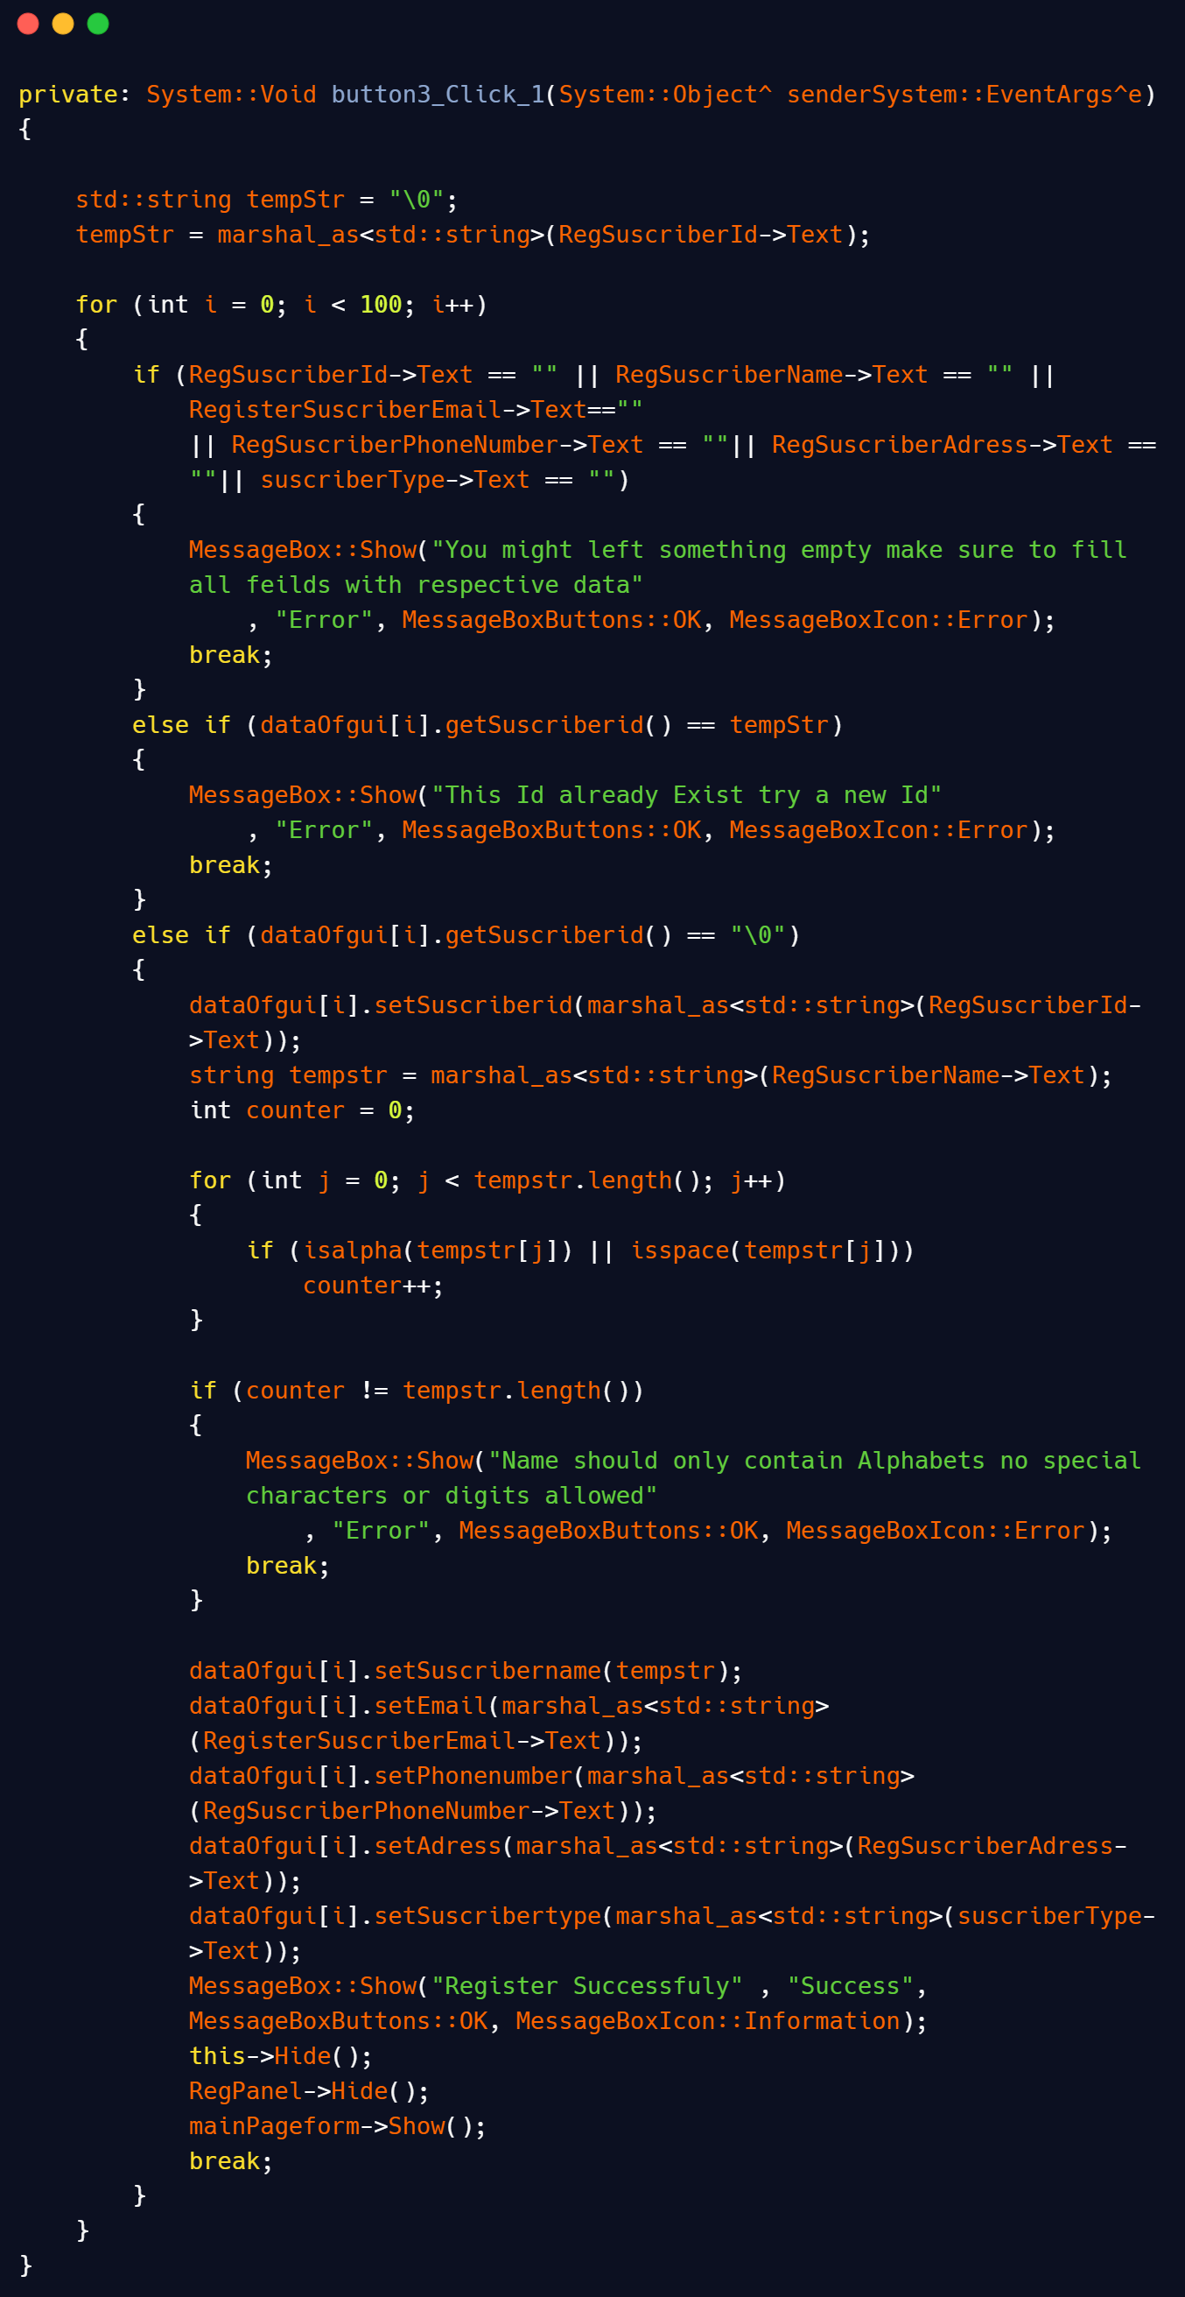

This code snippet contains the complete backend code of Subscriber registration page. In the first line we apply same validation logic for empty fields which we use in previous part of the code. The condition is to ensure that the Subscriber id/password is unique and won’t exist before. In case if user accidentally set a password which exist before it simply displays an error message and breaks the loop and forced the user to try a different password. If the entered data is not able to satisfied first two conditions then setting part of entered data comes into the picture. Here, we simply set the entered data through class setters functions but wait what if user entered digits in its name to surpass this problem we also put a small validation in the body of that code here, it check the value of SusbscriberName coming from input field contains alphabets only by using isalpha function for this purpose we use a counter in the body of the condition. So counter simply increments its value by one if there’s an alphabet in that index of string and if counter value is equal to the value of length of that string it means user enter valid data and it simply sets this data using setter function otherwise it will prompt an error message which informs the user about his/her mistake. Now we discuss the Login part of the subscriber☺.

When User press the button login as a subscriber then the below code snippet executes which displays the Subscriber password form and hide this first form.

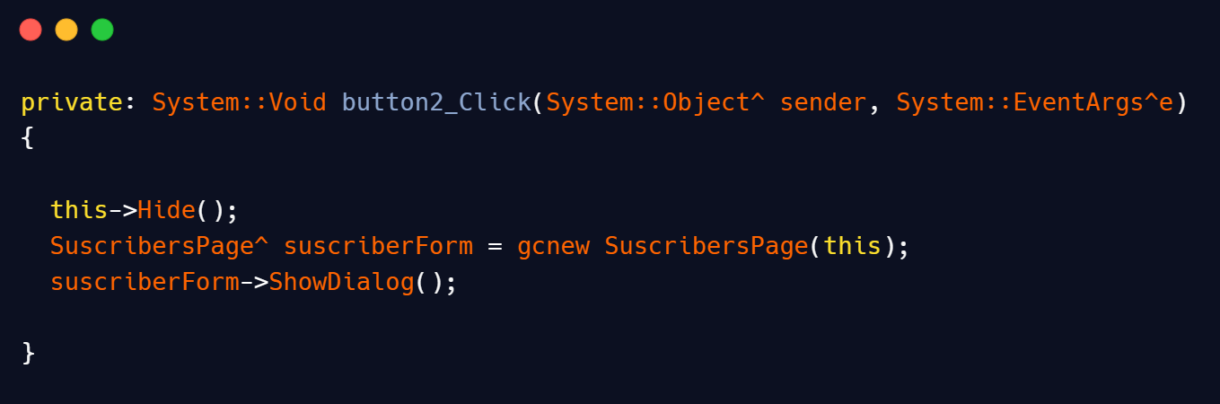

We explain almost alike code in previous pages and not need to explain here but if you find difficulty to understand it read explanation of similar code in previous pages of this documentation. When the user switch to login page of the subscriber now it’s time to login using subscriber’s id which the user set during registration phase. The code which makes logging in of the user functional is in below snapshot.

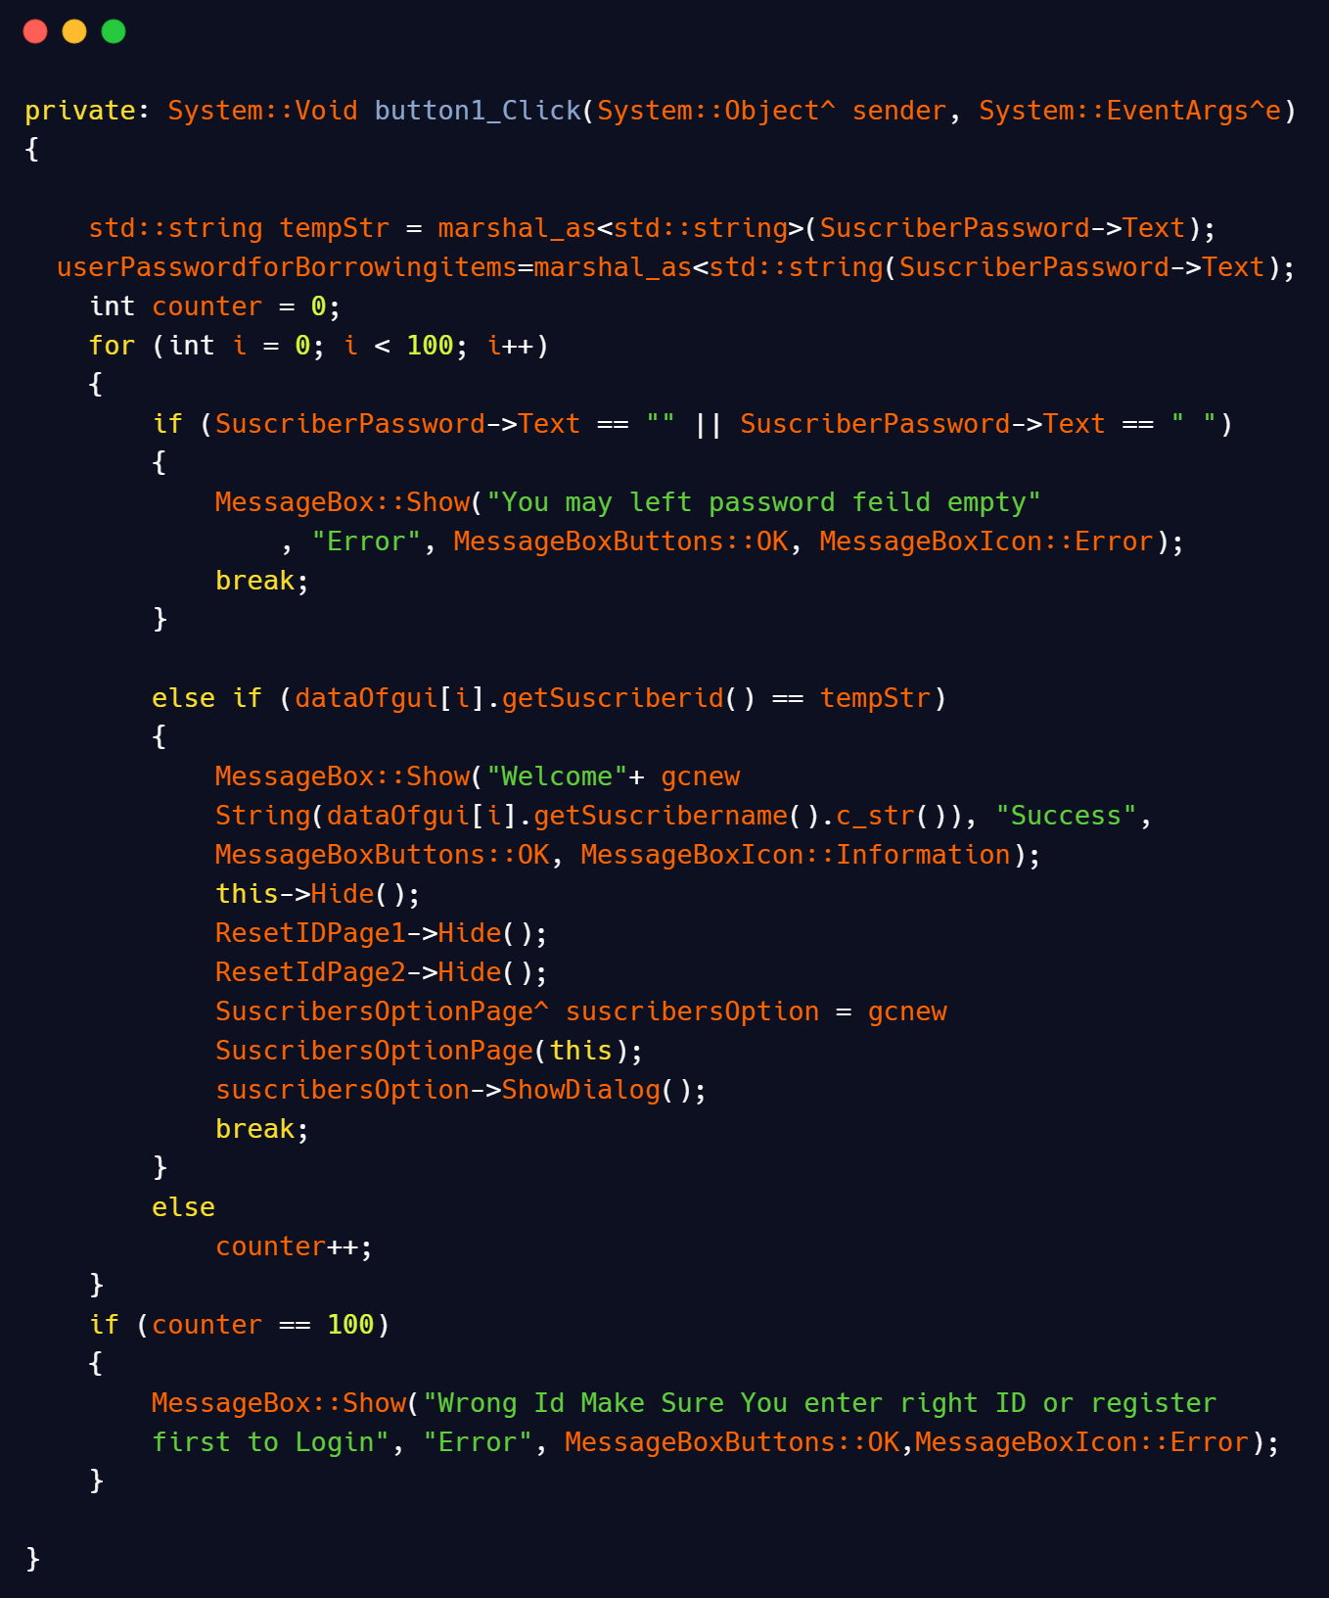

This snapshot consist of all code behind login button. In the first condition we apply the same validation logic for empty fields that we apply in previous codes. In the second condition we apply login for login and switch to the next option page available for subscriber. When user entered correct Id then a welcome message is prompt on the screen with user name and control is shift to the option page and this page is hide. But what if entered Id does not matched to the previous Ids so how we inform user that Id is incorrect or does not exist. To fulfill this requirement we set a counter in the loop whose value keep on incrementing by one if upper two conditions not satisfied and if the value of counter is 100 means not any of upper two conditions satisfied so it simply display an error message to the user that, you might enter wrong id or id does not exist and forced user to Re-enter correct id which belongs to him/her. But what if user forget his/her id, then he/she should register again? No need for register again. You simply reset your id. But how it’s possible. The below code snippet for resetting of id tells this answer.

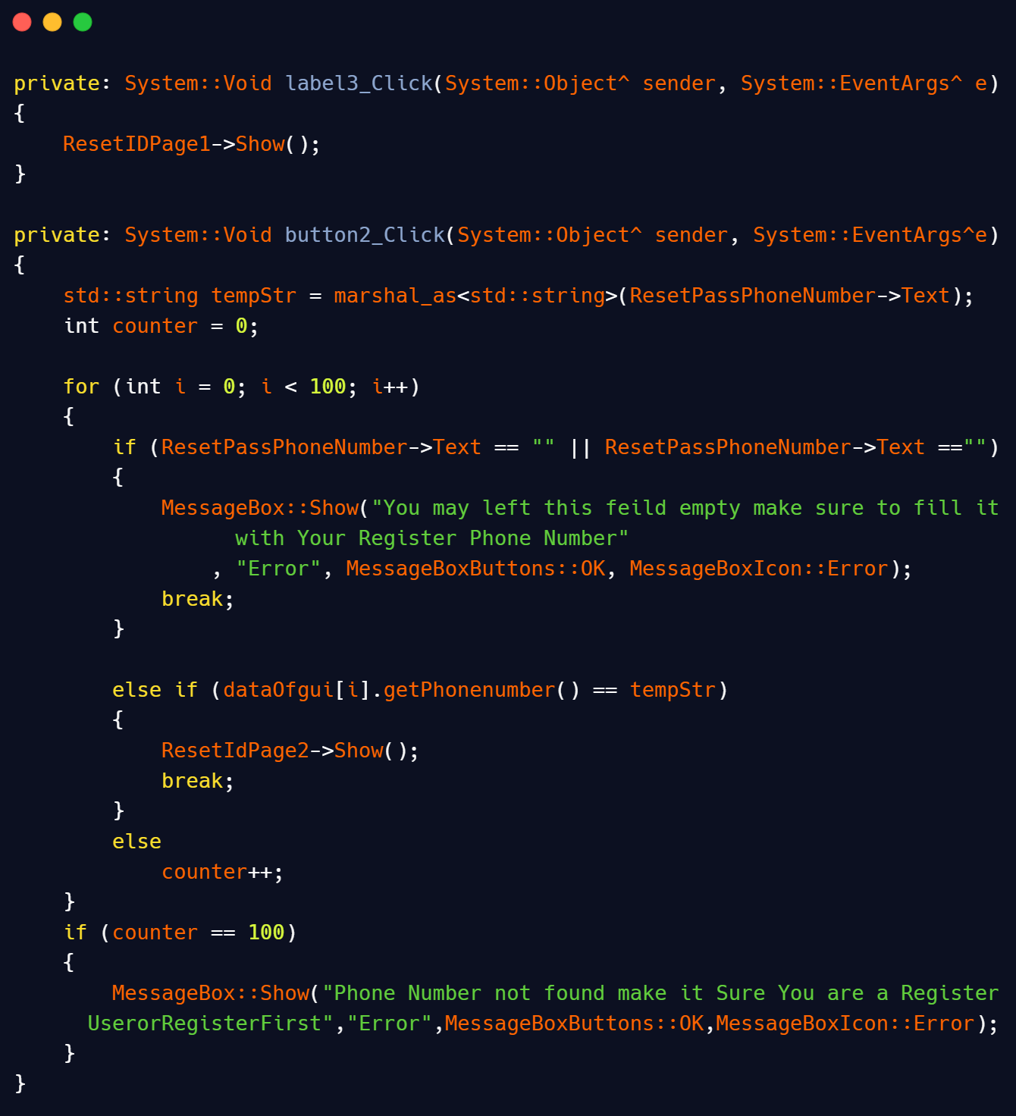

When we click the Reset id button it simply display a panel which’s code is on the top in this snippet. This panel will asking the user to enter his/her registered phone number to reset password. In the second condition, It matches the entered data to the previous data of the phone numbers and if any of data is matched it simply redirects the user to the next page where he can entered the new Id he want to set as his/her password. Now, when user log in then we move to the code of the Subscriber option Page.

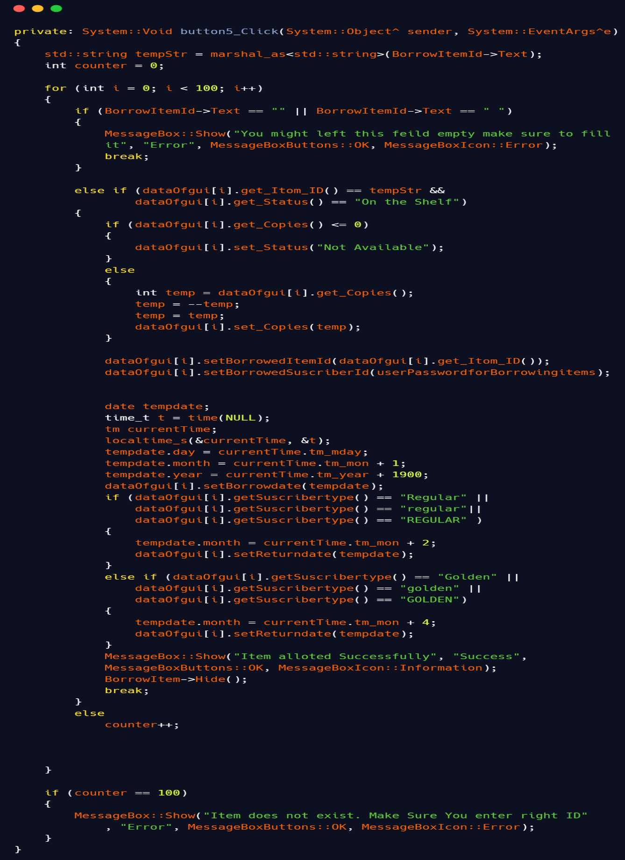

This code snippet is for Borrowing an item which follow same validation logics for empty fields as explain in previous snippets. It simply matches the entered item id to the available item ids and also with the status ‘on the shelf ’ which means item is available for borrowing. If this is the last copy of the item then this code sets its status to ‘not available’ which means the item of this id is now not available for borrowing or if it’s not the last copy then it simply decrements one from the number of copies. If the item is borrowed then we have to set its returning and borrowing date to keep the record for this purpose we use predefined datatype time_t and tm which we are able to use by importing <ctime> library. As given in requirement part if user is a regular one then he\she has 30 days to return an item or if he\she is a golden one then he/she has 90 days to return an item the code to make this thing functional is mentioned in the given snapshot with the help of two conditions. What if entered id does not match to any of the previous item’s id. In that case it simply displays an error message using Message box as we can see in the following snippet. It’s all for borrowing part now we move to returning part, the snapshot of the code of the return part is below.

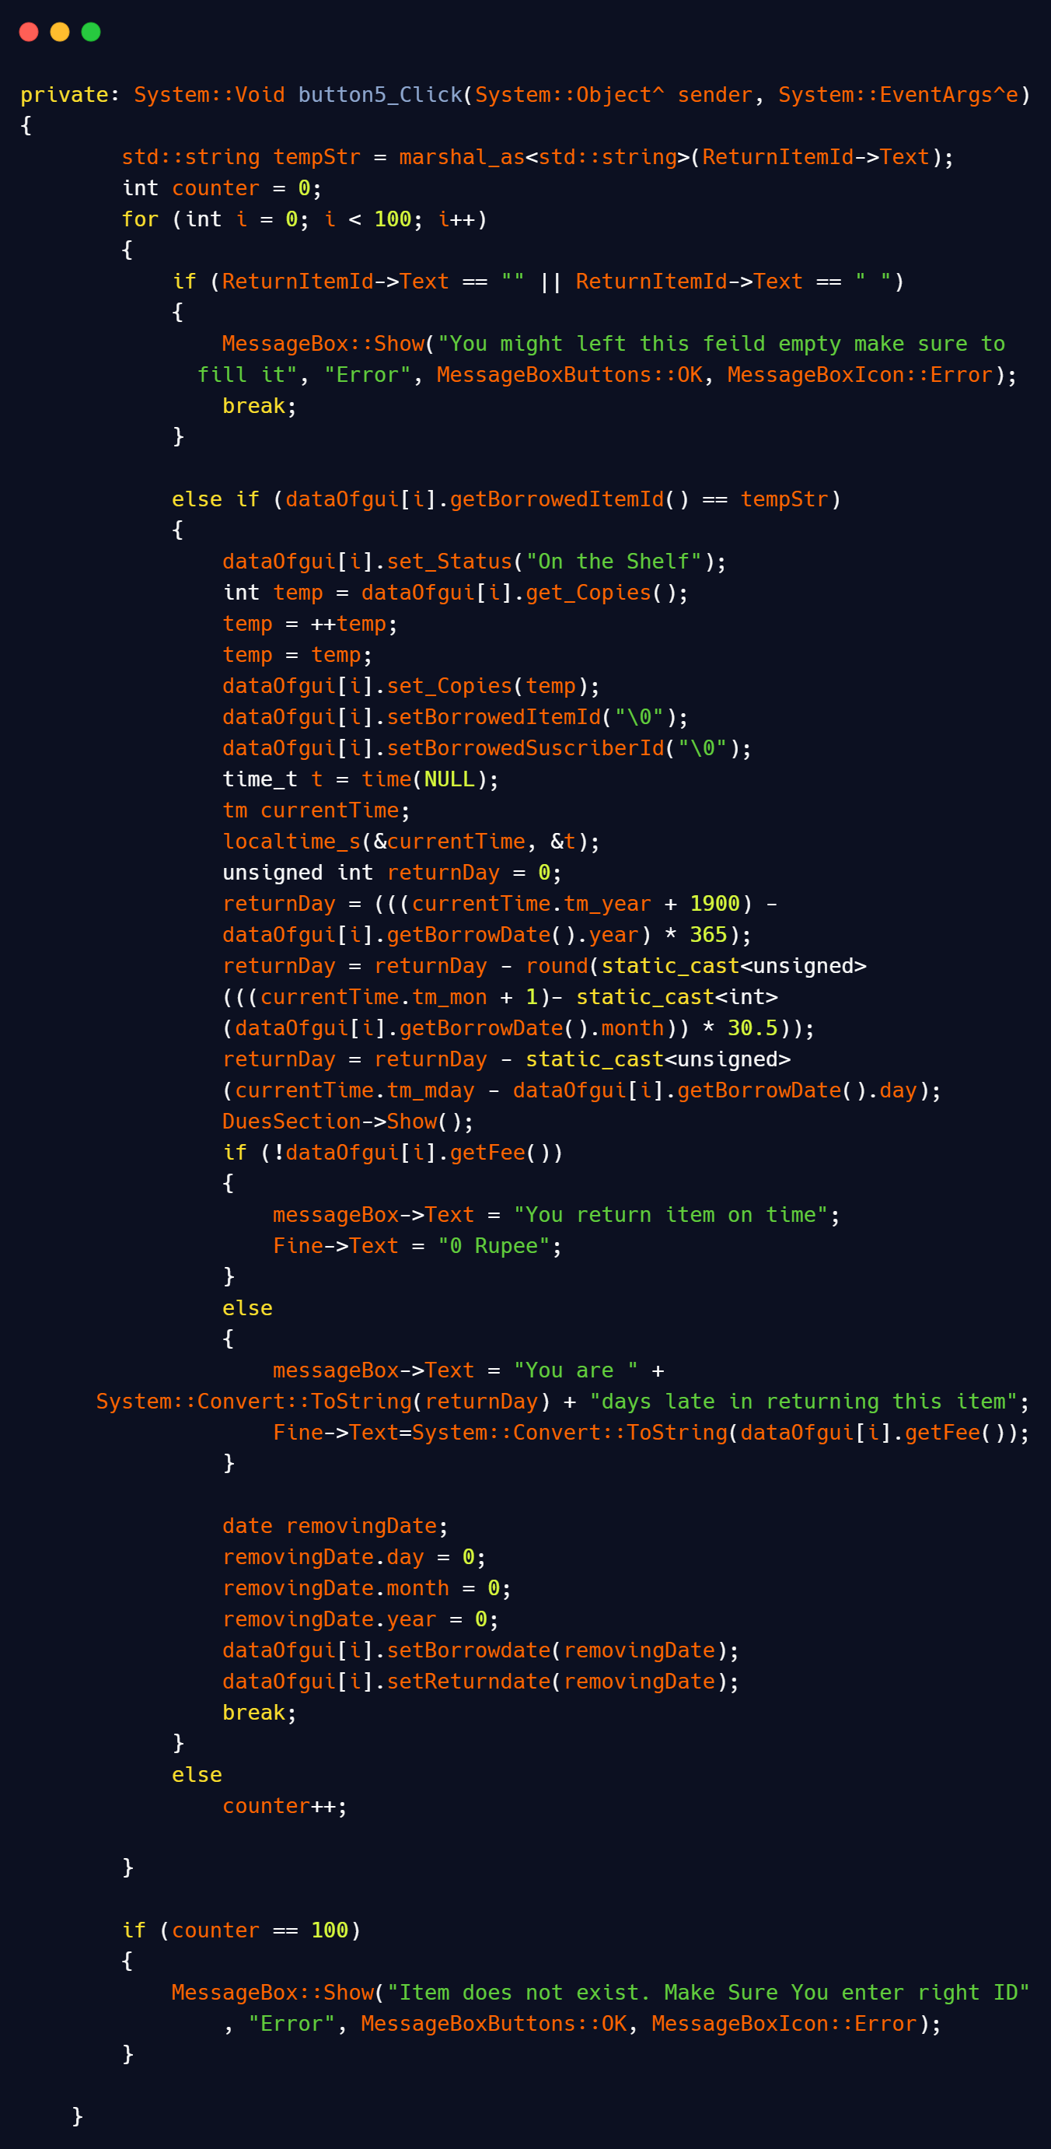

In this snapshot we explain the backend working of return an item it follows same validation logic for empty fields. If the number of copies of the return item is zero it simply change its status form ‘not available’ to ‘on the shelf’ and if the number of copies is greater than zero it simply increments a one in its value. Then we come to fine we use again time_t and tm to calculate the number of days from borrowed day to current day and if in the case of a regular user days are greater than 30 a dialogue box will pop up that tells the amount of fine and late days to the user and same in case of golden subscriber if item returns on time a dialogue box will popup that tells the user you return item on time. We make this dialogue box using panel so it means we simply show a panel. And if the entered id does not match to any previous borrowed id. It simply display an error message of id does not exist. But how a user identify which items are available for borrow? In that case List of available items come into the picture when we press available item button the following code snippet execute:

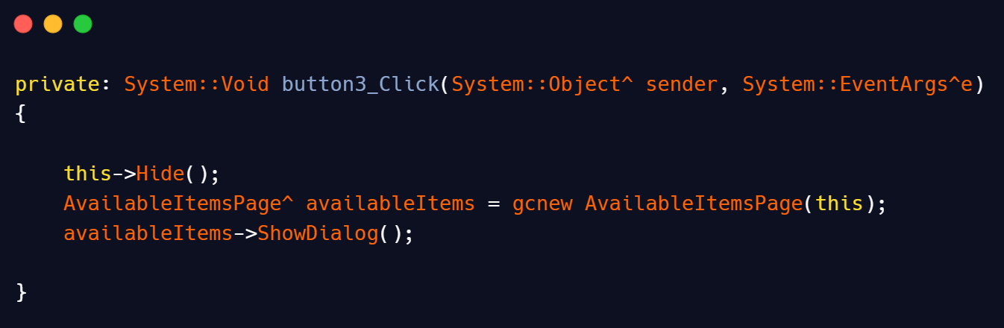

This snippet hides the previous form and display the data in a tabular form. But how we achieved this tabular form? To achieve this form we make a function and call it continuously in a loop in constructor of that form

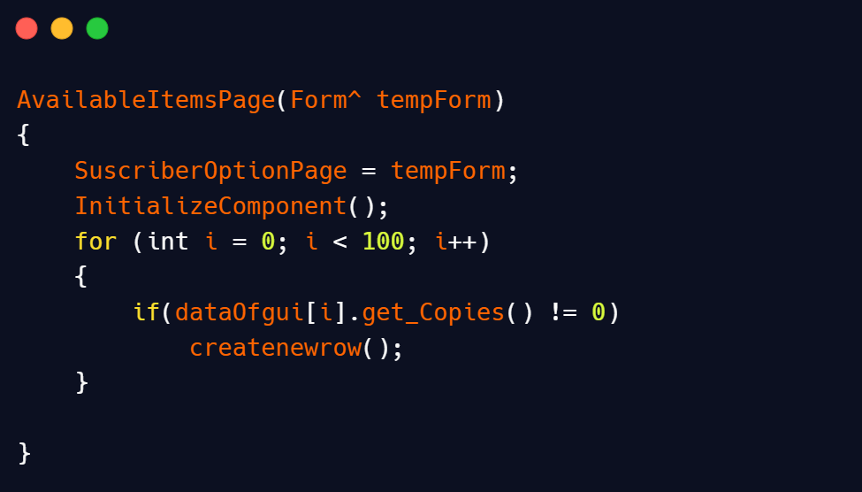

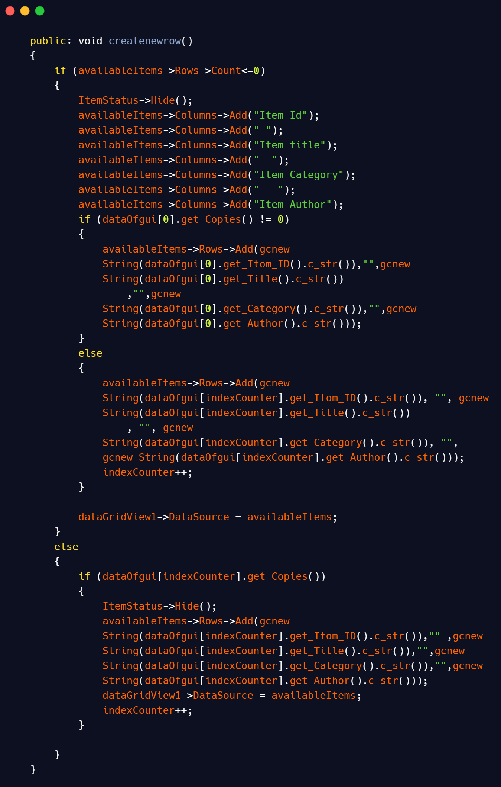

The working of this function is same and we explain it in admins part in the form of **overdue items**.

Hurray we have done all the coding part of the GUI and classes☺. But wait a minute, what happened if we close this application is all the entered data is lost? The answer is no, we make some functions to store data at end of the application. The snapshot of the end button is given below.

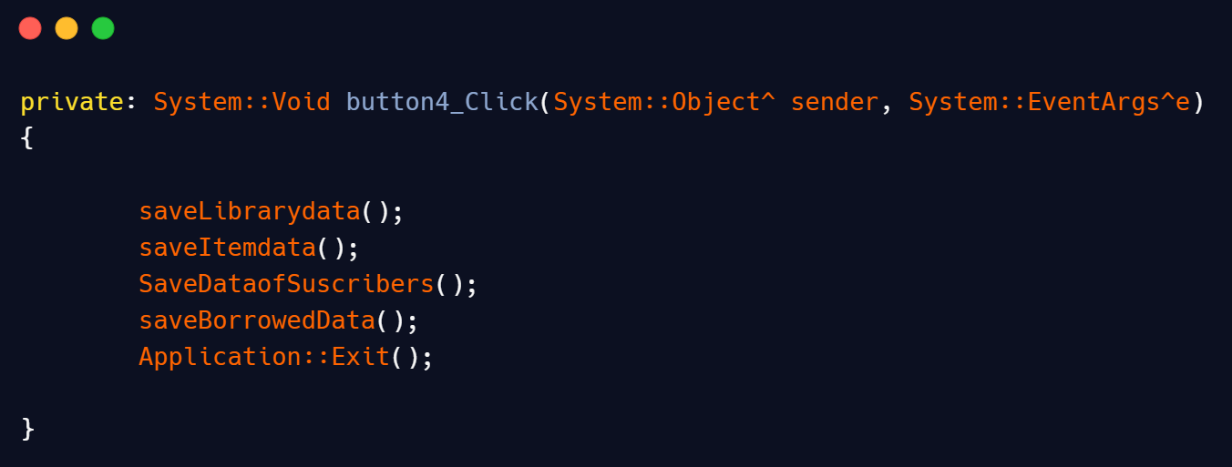When user pressed the End button, all storing functions call which are used to store data from objects to files. The snapshot of the code of the storing functions are given below:

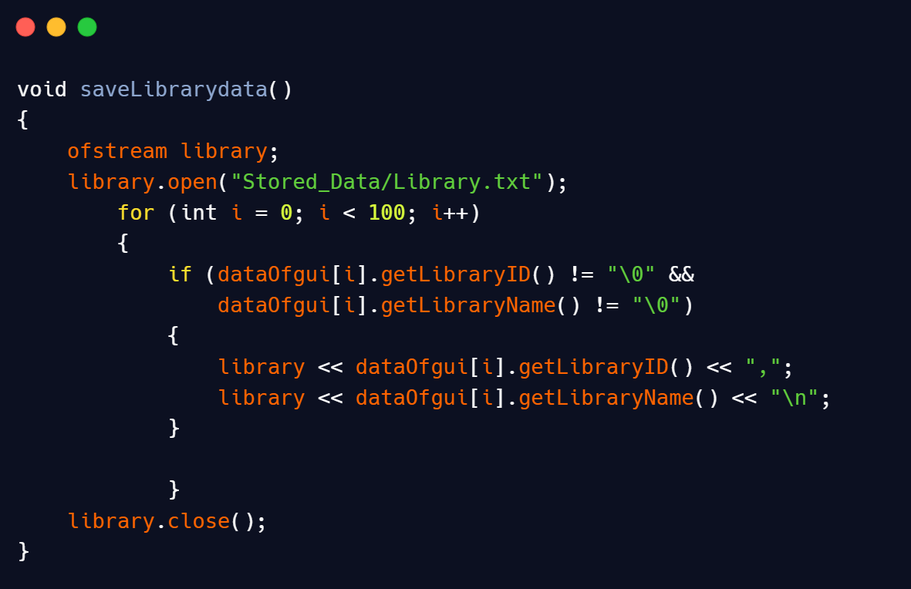

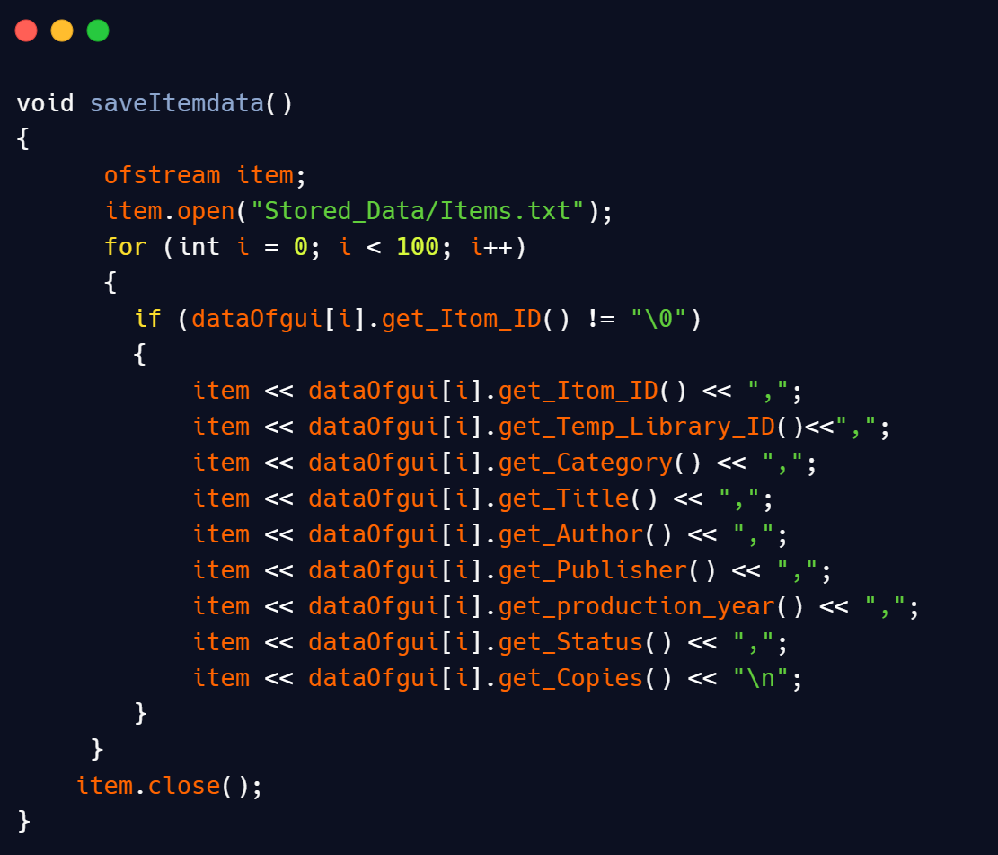

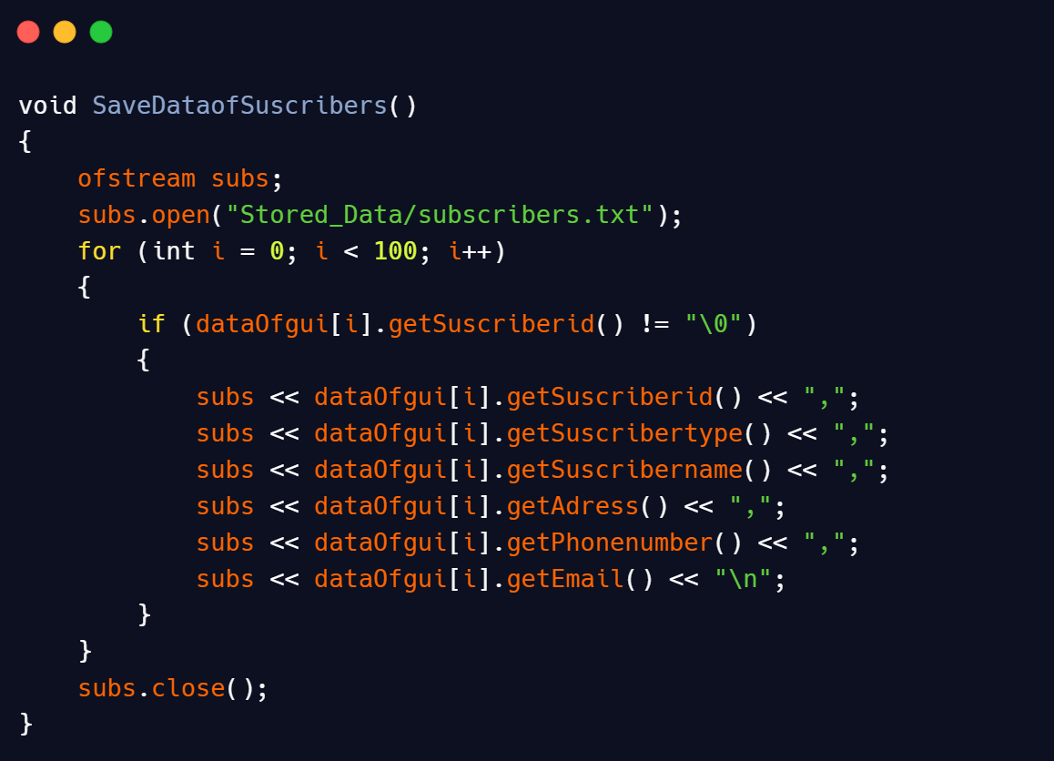

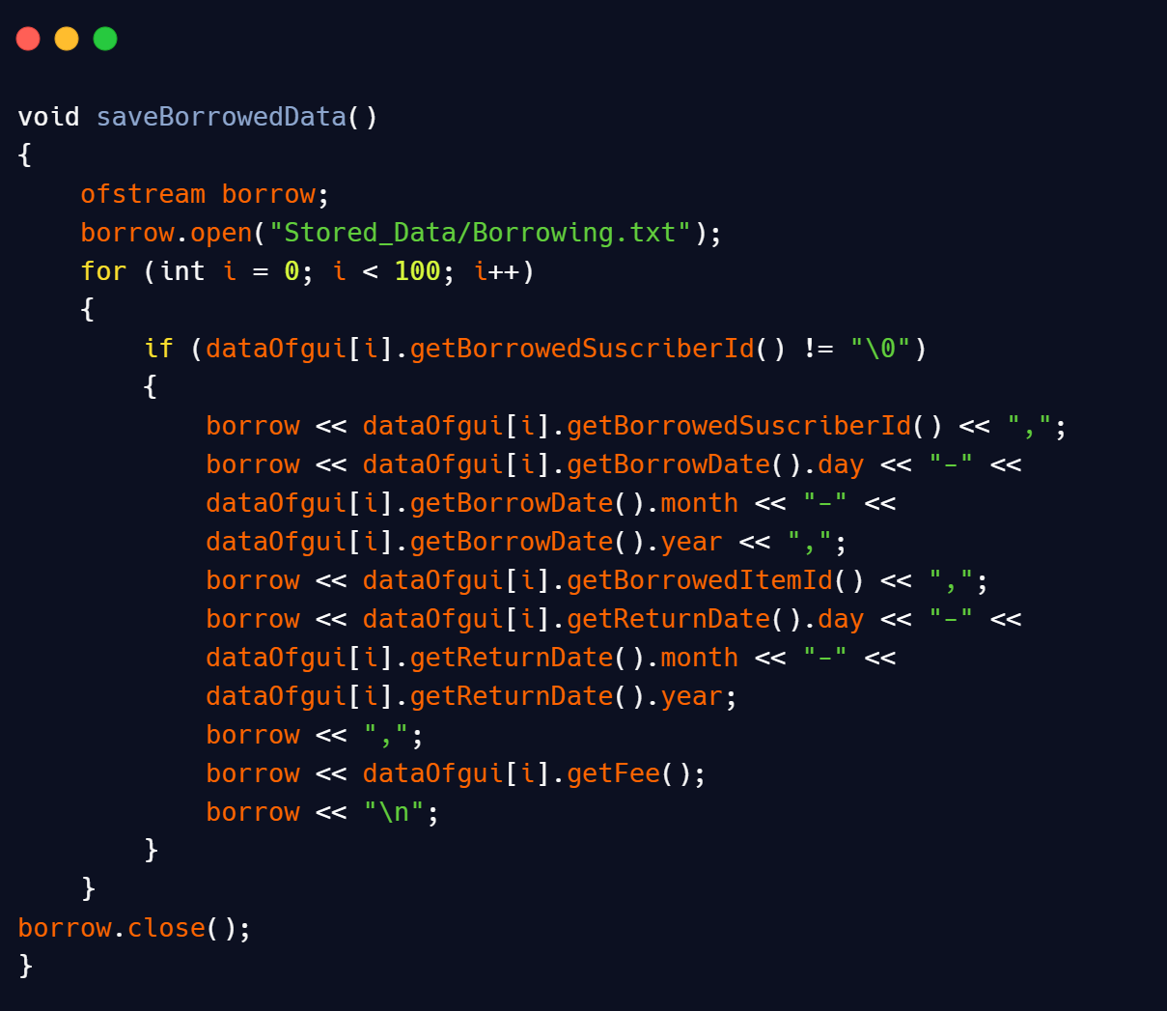

These are all Functions for storing data. These functions store data in the respective file with a comma as a separator between data of two members. We load this data when we start this application and loading part is explain in the beginning after the explanation of classes. Hurray! We done with technical part now we move to User guide.

**User Manual**

The following is a **guide for the users** to understand how he/she can use this application and its features.

**Starting Page**

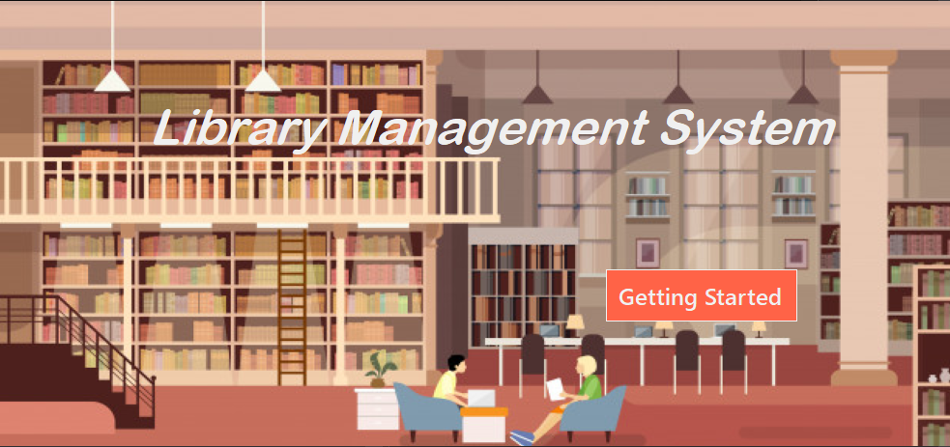

It’s the welcome page of our product by pressing ‘Getting Started’ the user is directed to ‘main options’ page mentioned below.

**Main Options Page**

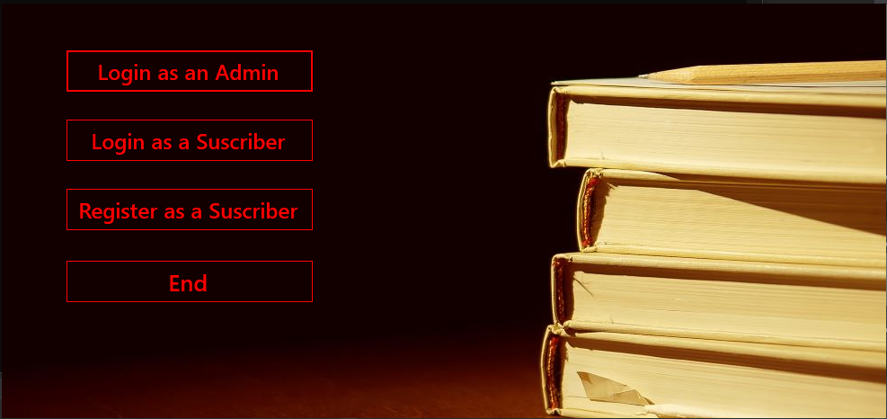

This is the **First page** of the app where different options such as **Logging In** or **Ending** the process are available. Depending upon the user they can either login as an Admin (if he/she has Administrative privileges) or as a Subscriber. And if anyone wants to login as a subscriber, then they have to **register** first or be an already registered subscriber.

**Admin Guidelines**

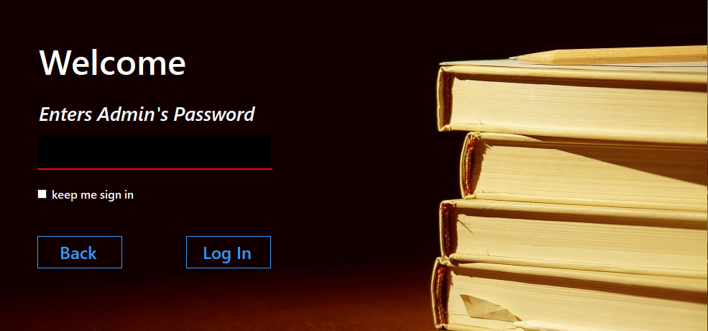

The **Admins Login Page** is used by the admin to gain access to the management system and to use the **privileges** they have as the Administrator of the product. The Admin just has to enter their password and click login. The Keep me signed in check box is used to save the password so that they don’t have to enter it while logging in again.

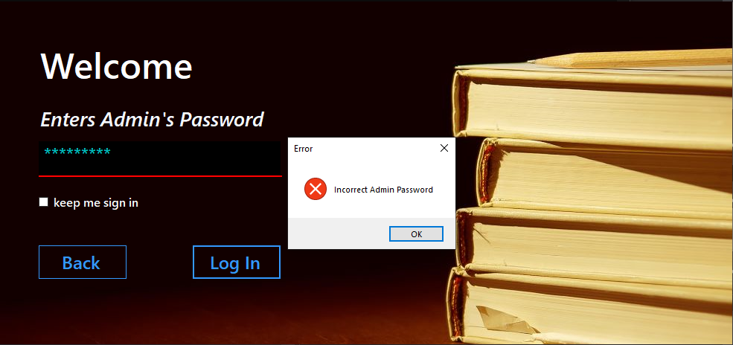

In case the Admin enters the **wrong password** he/she will be shown a dialog box with an error message saying that the password they entered is incorrect. After clicking ok they will again be asked to enter the password.

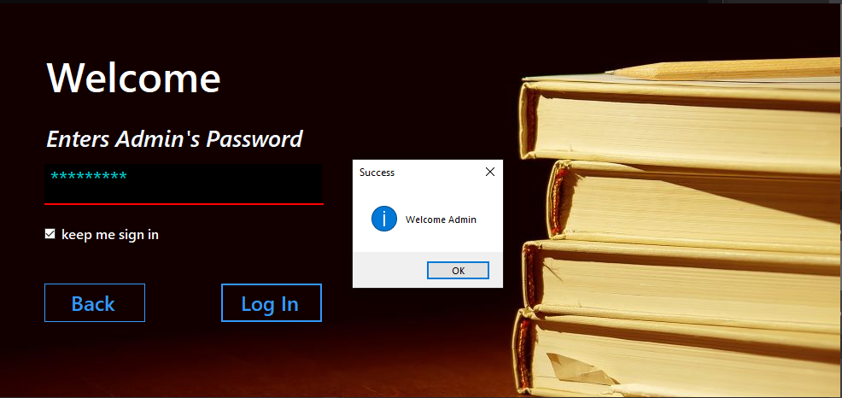

After the Admin enters the **required password** and clicks on the login button a dialog box will pop up signaling that they will be redirected to the systems Admin Panel.

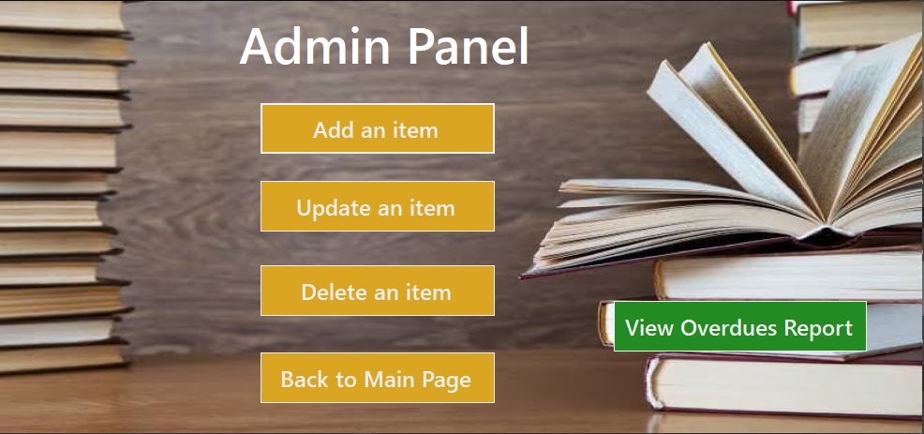

After entering the required password, the admin will be redirected to the admins panel where he/she can access the various options available to the admin such as **Adding**, **Updating** or **Deleting** an item. He can even **view reports** on Items whose date is overdue to check the IDs of users who have been fined. There is also a button “**Back to main page**” which allows them to jump back to the main page.

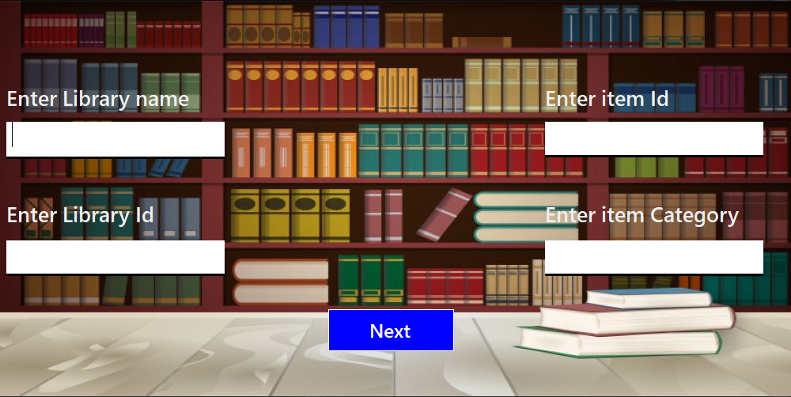

To **Add a new item** the Admin has to enter all of its credentials such the name and id etc. After entering the required information he will press next and depending upon the validity of his information he will be shown a dialog box.

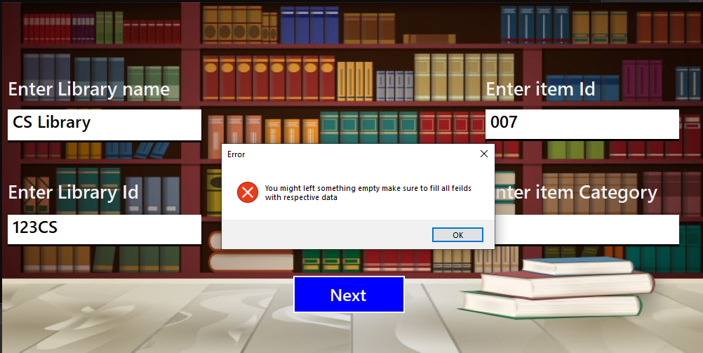

If any of the fields are **left** **empty** a dialog box saying ‘you might have left something empty’ will show up and on pressing ‘ok’ the user will then be asked again to fill in the credentials.

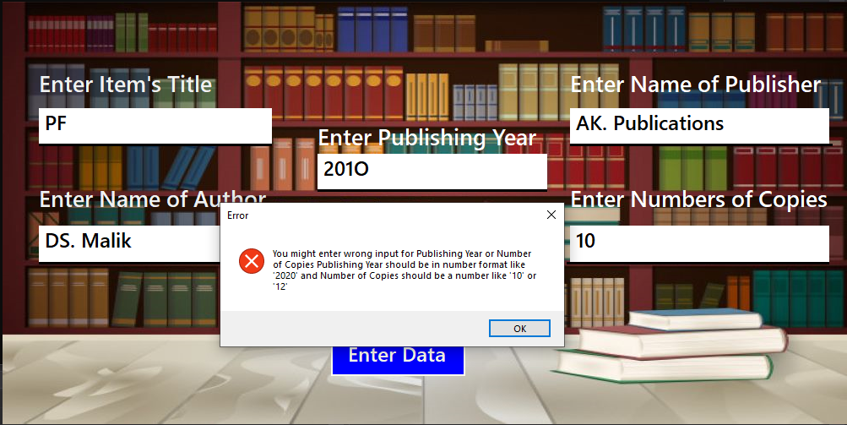

While entering **the credentials** the user will need to fulfill certain validations. Like the year can’t be in any format other than the one given as an example i.e. “**2020**”. **No** **symbols** or **letters** of any kind are acceptable and will just give error messages. Similarly, the Number of copies entered must be a numerical value. If anything else is entered a dialog will appear displaying the error message. On clicking ok the user will again be asked to enter the info.

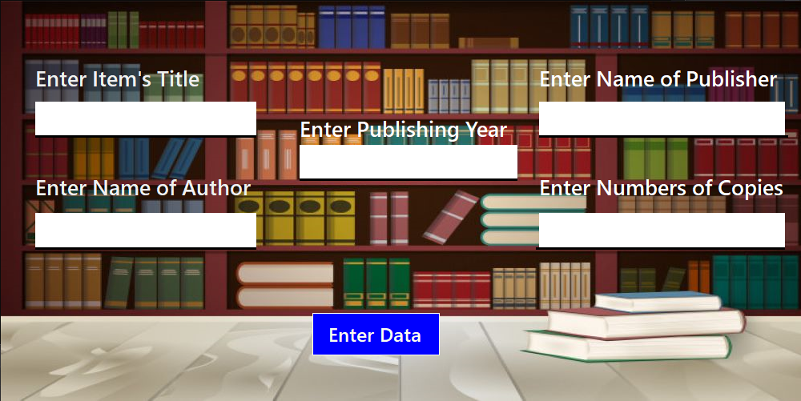

After entering the fields, the user will then be prompted to enter the **information** about the item they want to store. Such as its **title, author and publication year** etc. After this information is entered the user can save the item they entered successfully.

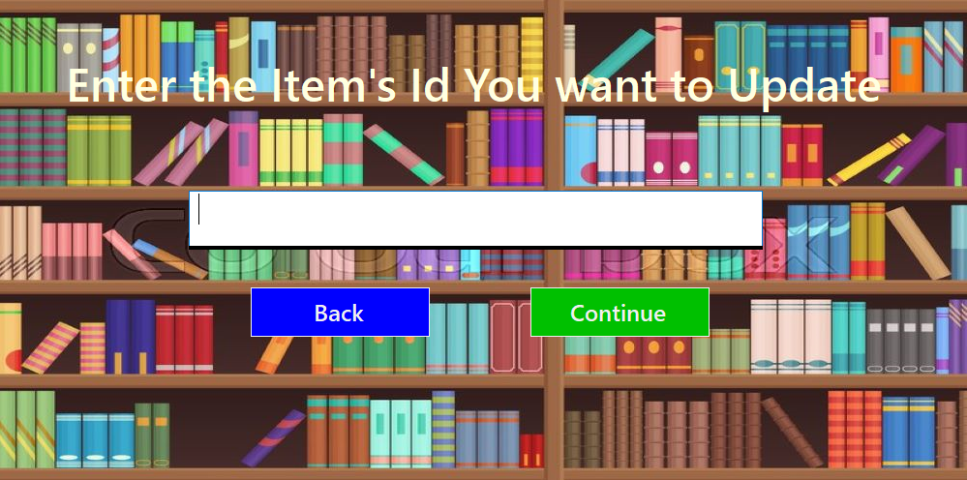

In order to **Update** an already entered item the user will asked to enter the **ID** of the item they want to update. On clicking continue they’ll be taken to the update menu. On pressing back they’ll be taken to the Admins panel.

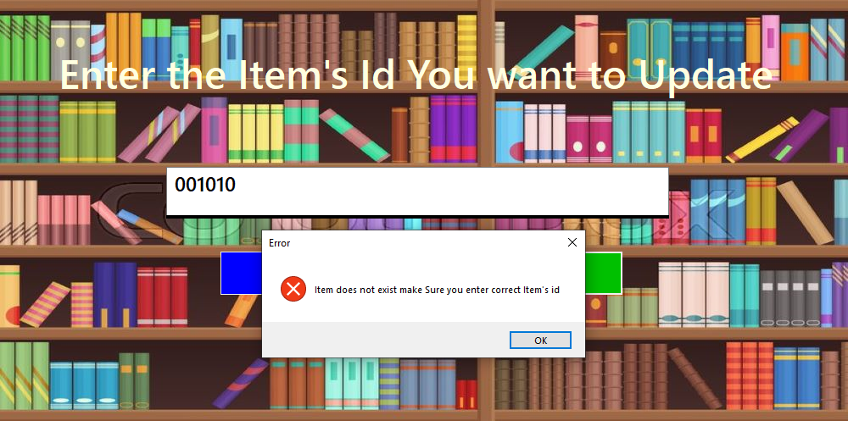In order to update an item, it must **first exist** in the system. If an ID that doesn’t already exist is entered an error message will pop up asking the user to enter a valid ID number.



After entering a valid ID, the user will be taken to the **Add Item page** where he can update the credential he wants to. He will again have to follow the validations which were required the first time otherwise the same error message will pop up.



After Adding the **updated items fields** successfully, the user will be asked to fill in the **information** about the item. This will again require the user to follow the validations. After this he just has to click on the enter data button and the Item will be stored.

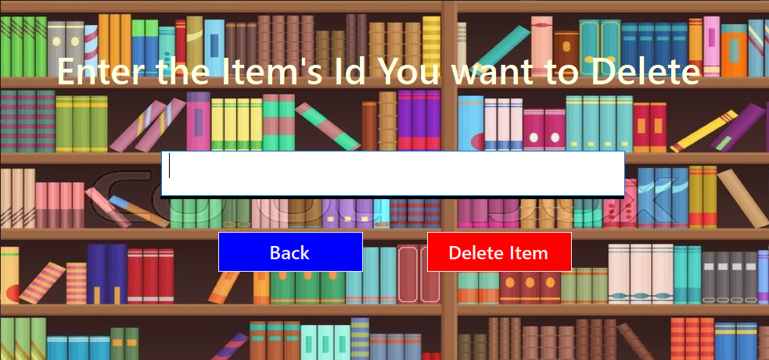

After this comes the option for **deleting an item**. The user just has to enter the ID of the item want to delete. And then click on the delete item button.

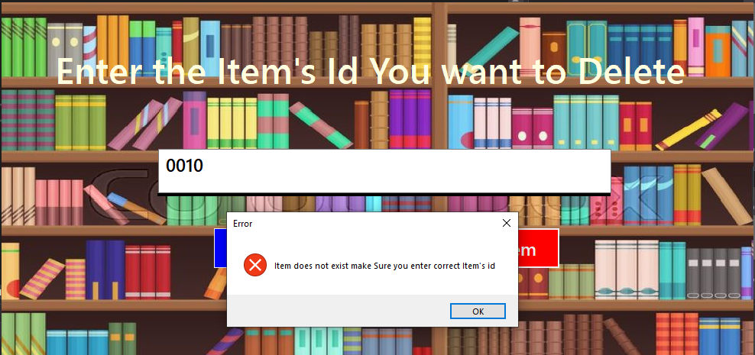

In case the user enters an **ID that is wrong** or doesn’t exist in the system they’ll be shown an **error message** saying that the item doesn’t exist. The user has to make sure that the item ID they entered is correct.

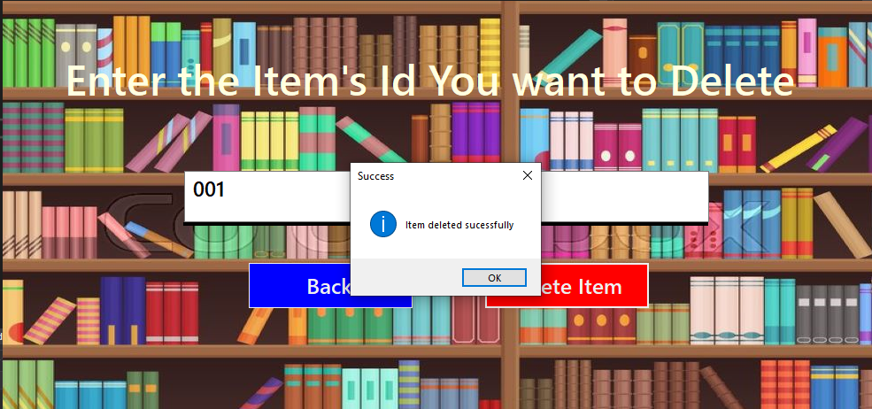

After entering the right ID number, the user has to **press the delete item** button. A pop up will appear showing that they have successfully deleted the item.

**Subscribers Guidelines**

**Registering as a subscriber:**

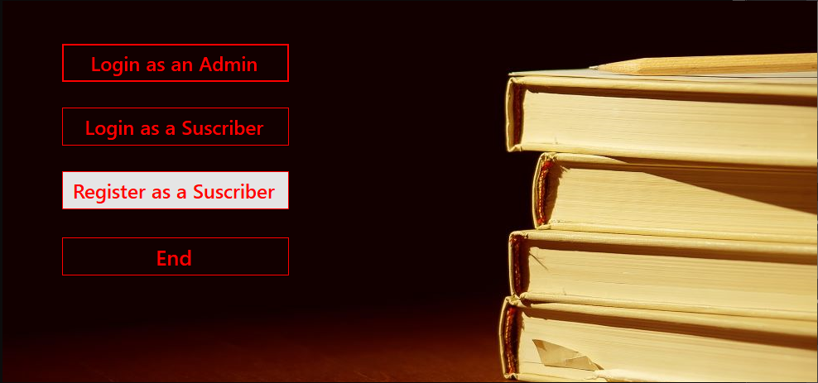

**To register as a subscriber** the users just have to click on the ‘Register as a subscriber’ button and they will be redirected to the registration page.



This is just a Welcome screen for the user. They can go to the registration page by clicking on join now.

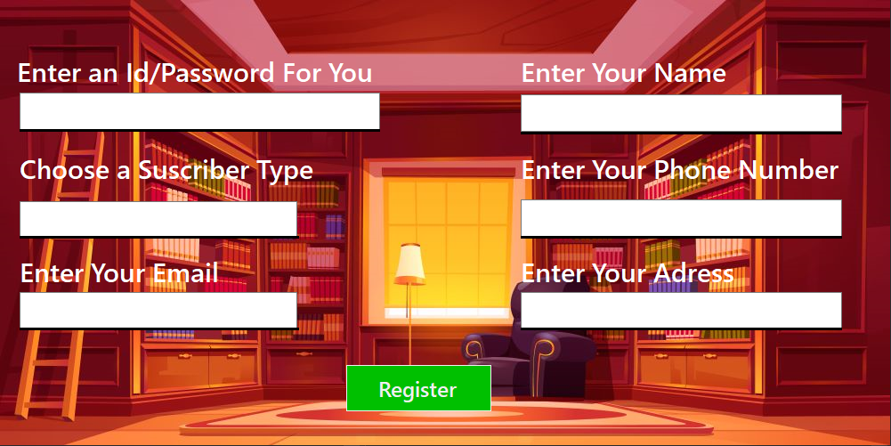

This is the **registration page for new users** who want create an account. Here they will be asked to enter the information required to create an account in the system.

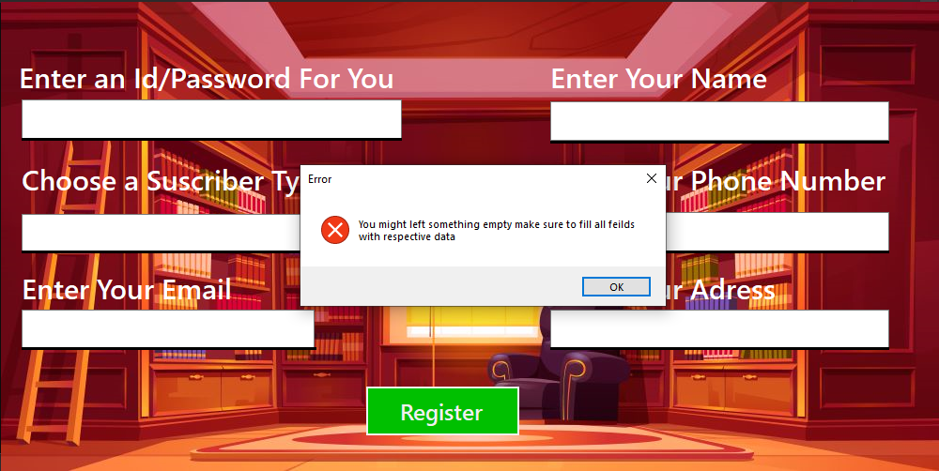

If the user **leaves** any of the **fields** **empty** they’ll be shown an error message and will be asked to fill all of the fields properly.

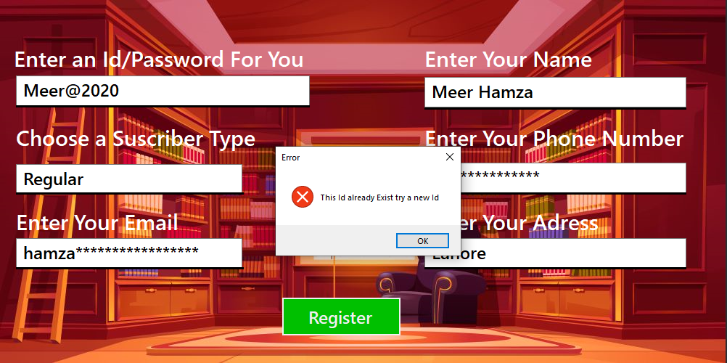

If the user enters an **ID that belongs to a previously listed subscriber** they will be shown an error message asking them to change their ID to valid option.

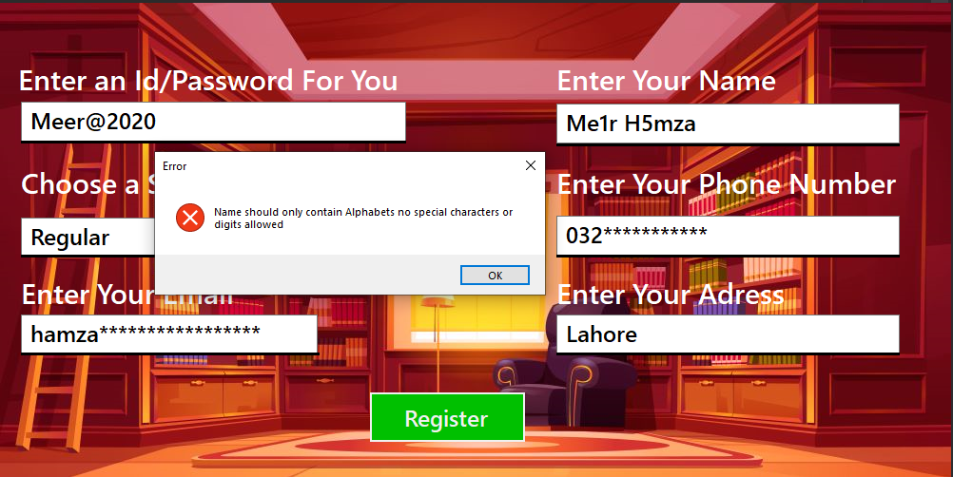

If the **name entered has a digit** or a **special character** an error message will pop up. The name must **only contain letters** otherwise it’ll be rejected. On entering a wrong name the user will be asked to enter the name again and again until he enters a right name.

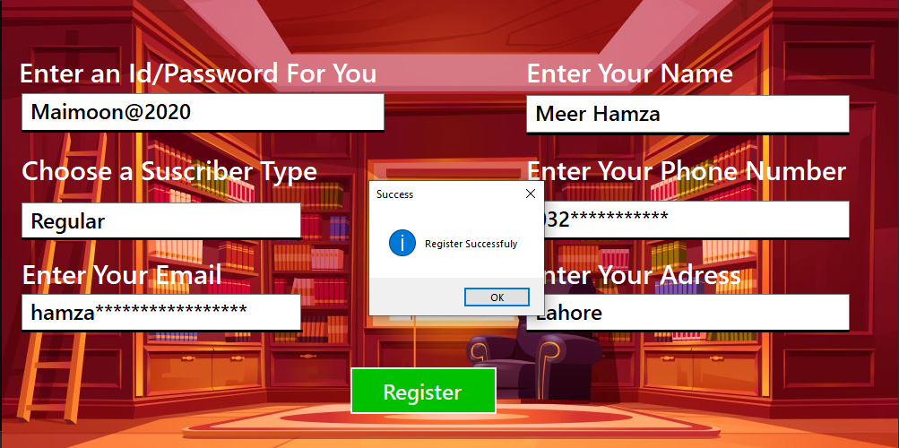

When all of the information entered is according to the valid requirements the registration will be successful and the user will be **registered into the system**.

**Subscribers options:**

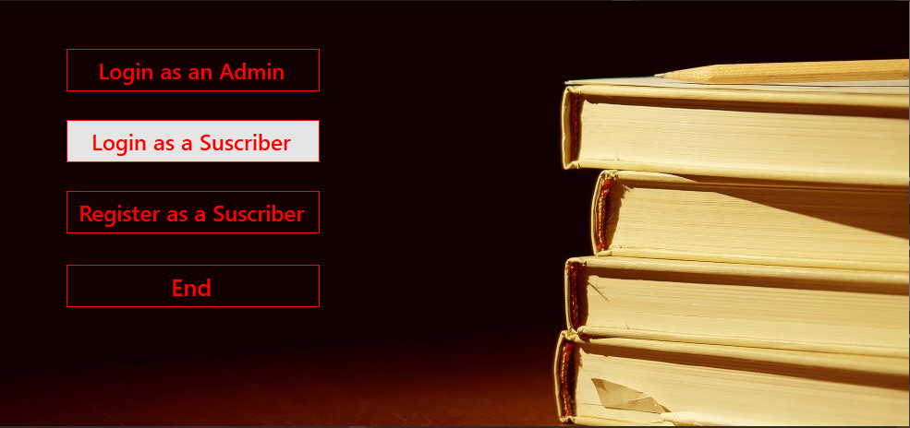

After registering themselves as a subscriber the user can now **log in** to the system as a subscriber from the first page.

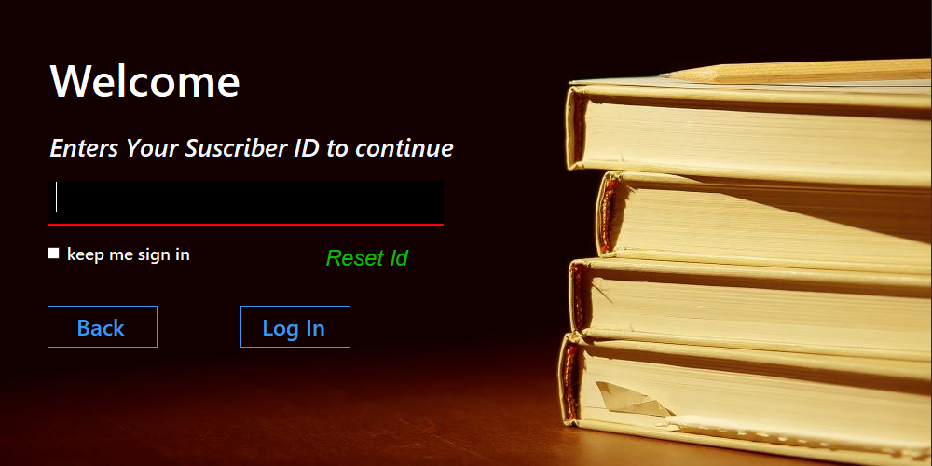

To log in as a subscriber the user will have to enter their ID and then log in to system.

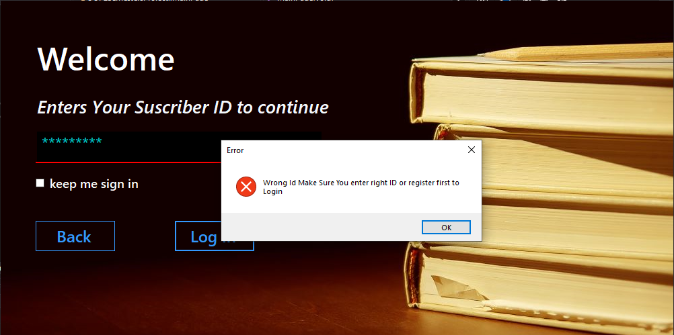

If the **ID** entered by the user is **wrong** then an error message will appear telling the user that the ID they entered is wrong after which they’ll be asked to enter the ID again.

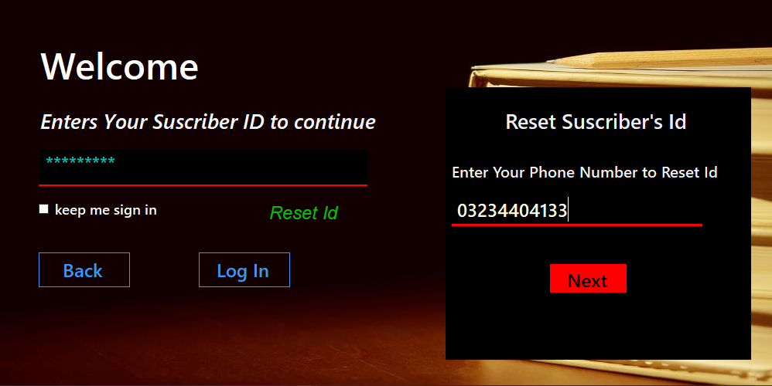

If the user has **forgotten their password** they can reset it at any time by using the “**Reset** **ID**” option. The user has to enter the **number** they gave while registering themselves into the system. After entering the number they will be given a **new password** which they can now use as their login password

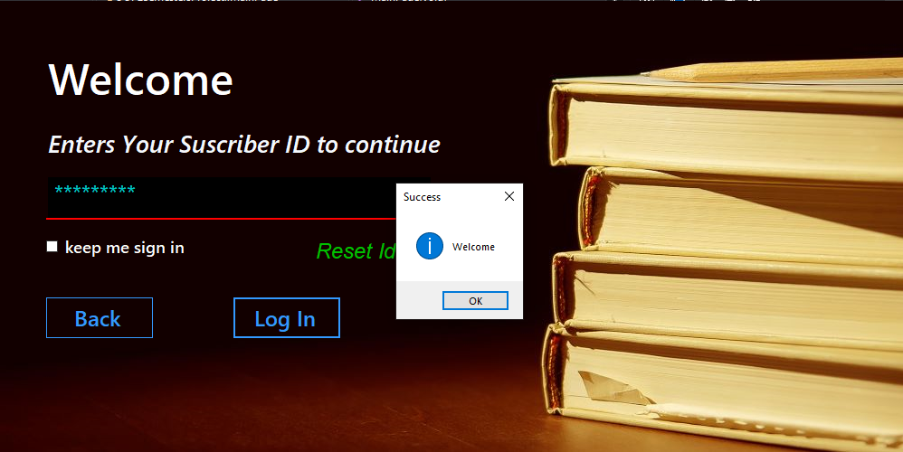

When the password entered is correct then on pressing Log In the user will be shown a pop up saying welcome and will be taken to the subscribers’ panel.

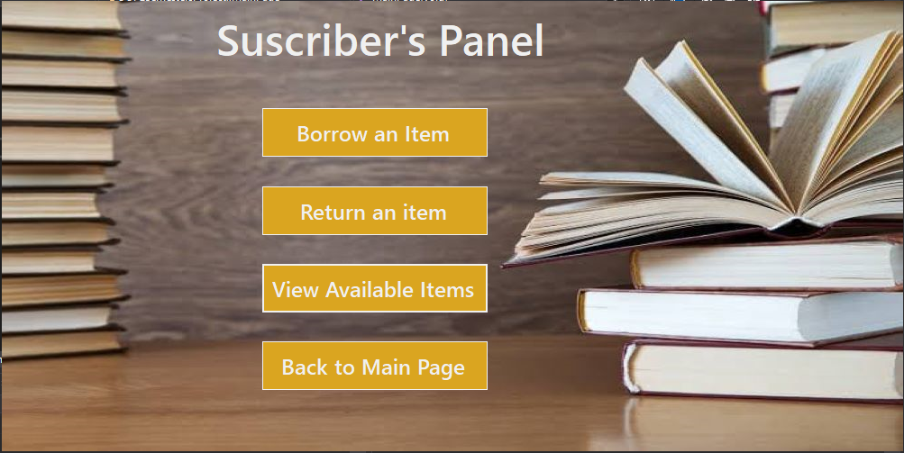

This is the **subscribers’ panel** from where they can **borrow** any item from the library. They can also **view** the items available and **return** an already borrowed item using this menu.

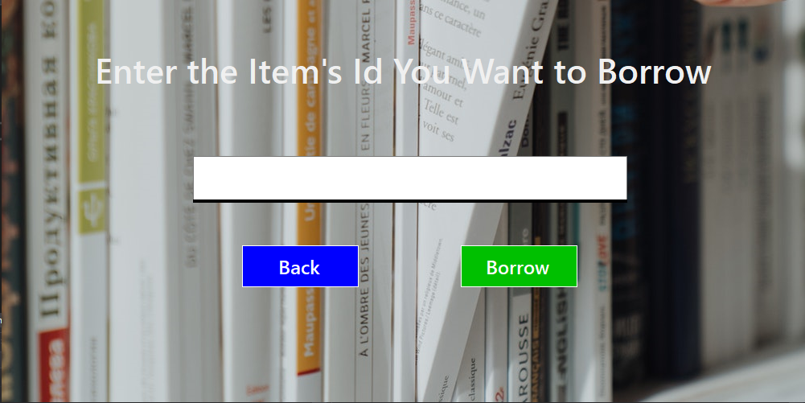

In order to **borrow** an item, the subscriber has to enter the items ID.

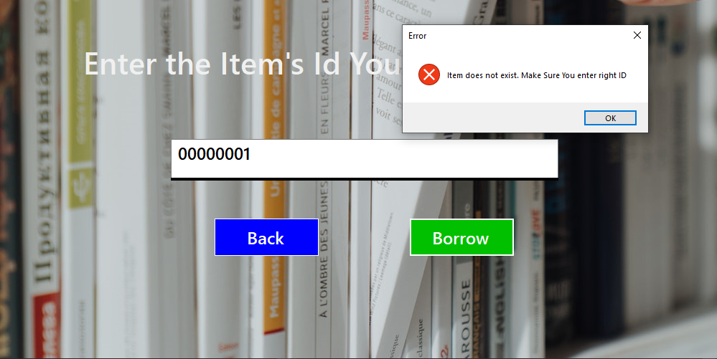

If the **ID** entered by the subscriber is **wrong** an error message will appear telling the user that the ID they entered is incorrect or doesn’t exist in the system. And the user will be asked to enter the ID again.

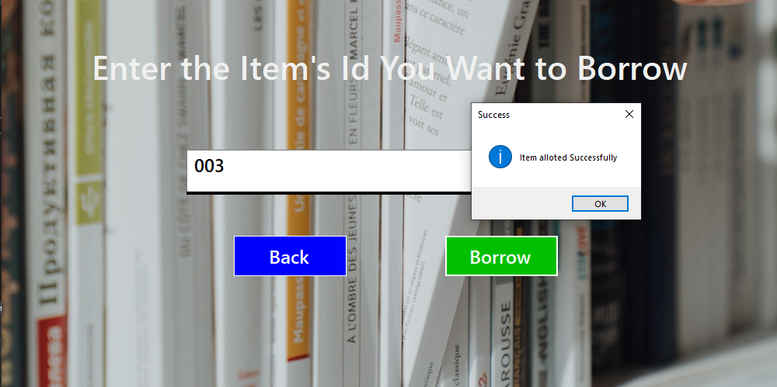

After entering the right ID the user will be able to borrow the item for a **specific amount of time**. And a pop will appear saying that the allotment of the item was a success.

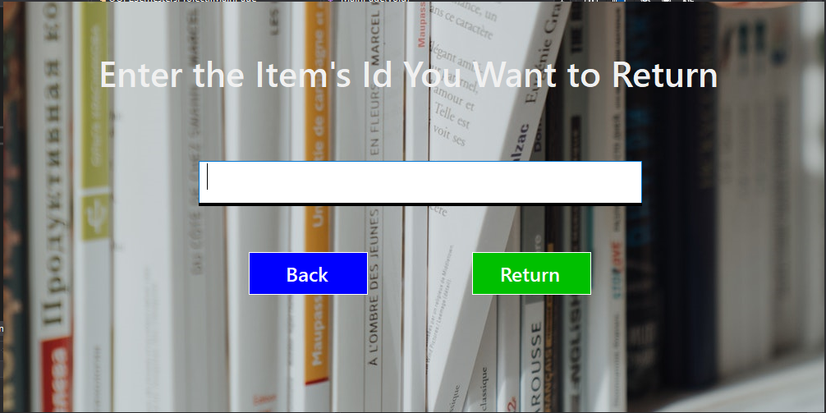

In order to **return an Item** the user again has to enter the ID of the item which they want to return. If the Id entered is **incorrect an error** **message** will appear otherwise the item will be returned successfully.

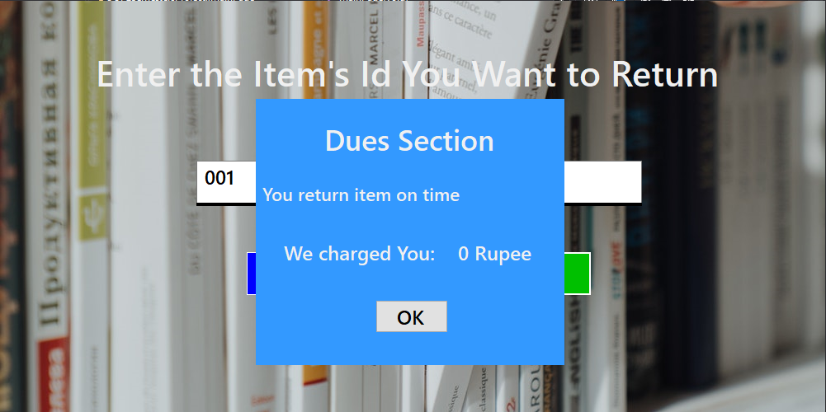

When the item is returned a pop up will appear showing them their **status**. If the item was **returned on time** nothing will be charged from the user **otherwise** a fee may incur.

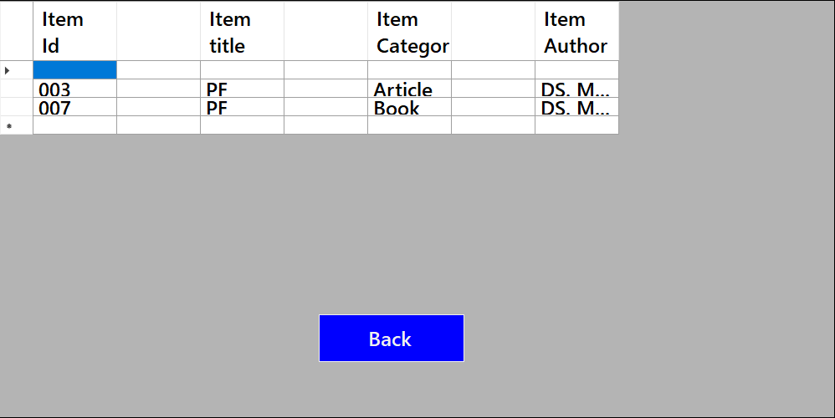

This is the **list** on which the subscriber can **view** available **items in the system**. From these he can choose if he wants to borrow any and then enter the items Id to borrow it. On pressing back they’ll be taken to the subscribers’ panel.

**Hope You Enjoy**

Written by Meer Hamza (2019-CS-29) and Maimoon Ahmad (2019-CS-42)